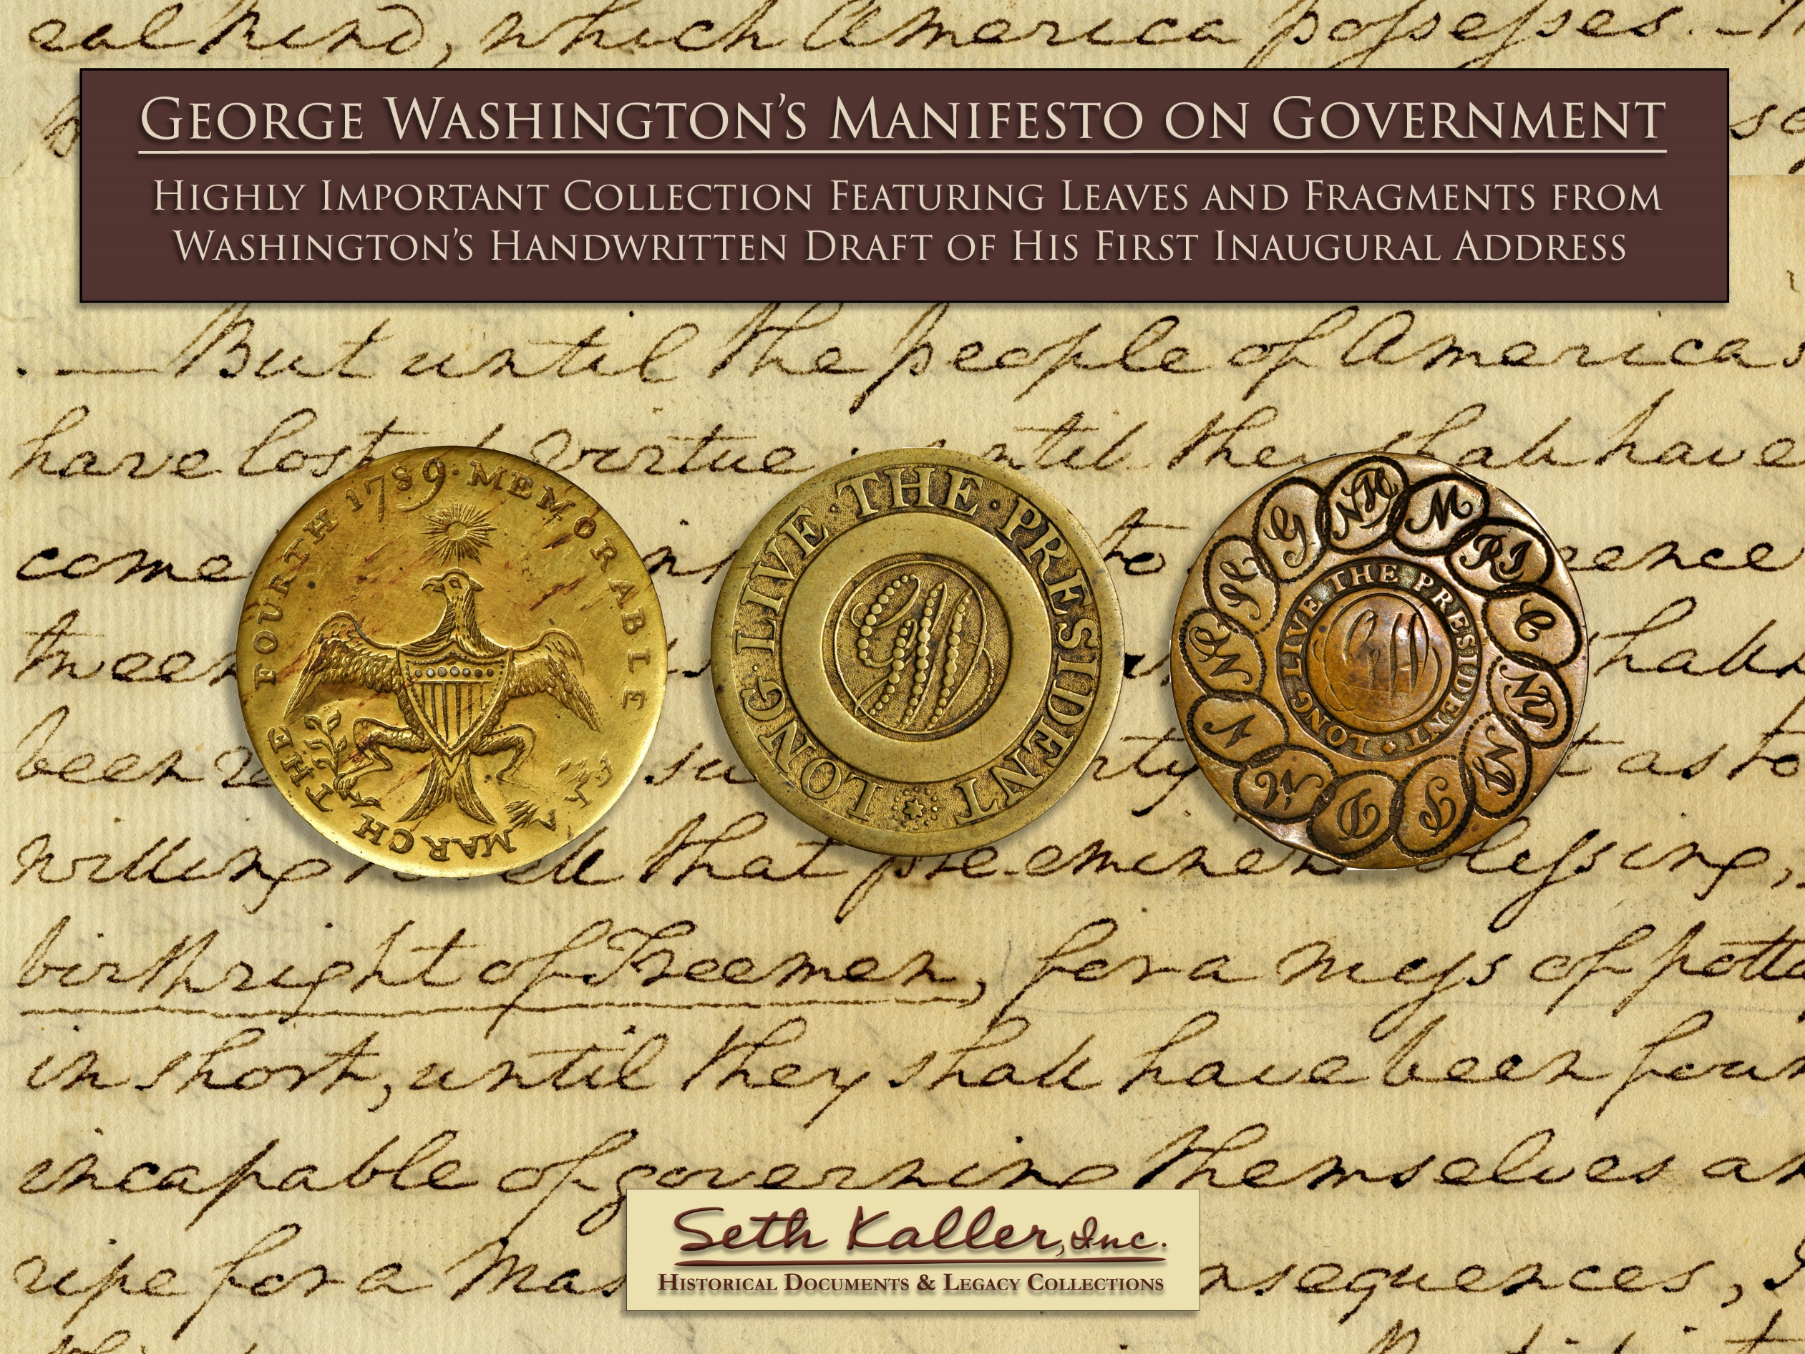

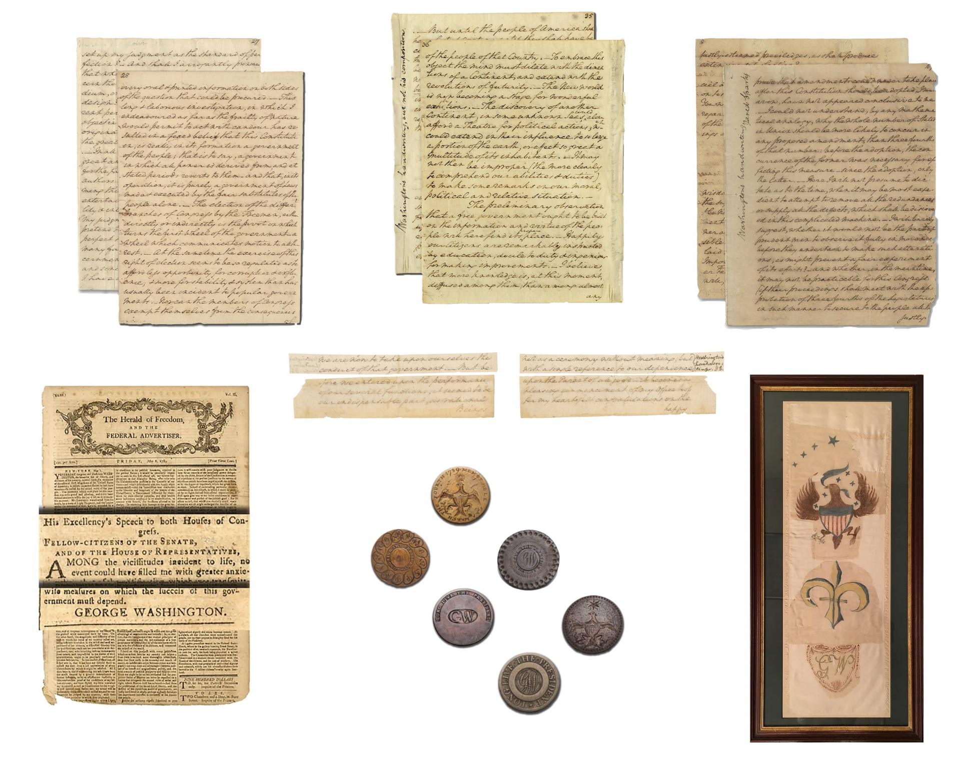

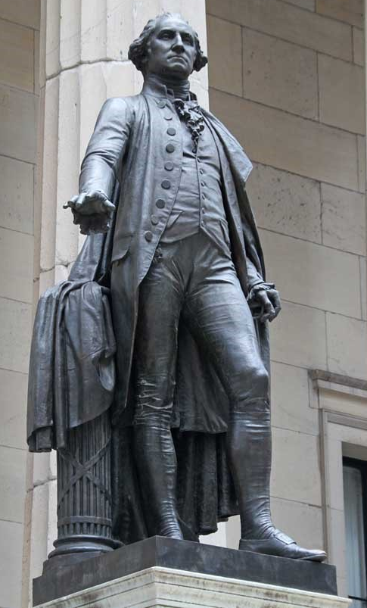
Contents

Introduction 4

Authorship of Washington’s Inaugural Manifesto 6

Our Collection Offering of Inaugural Leaves & Fragments 10

Census of Known Complete Leaves 18

Original 1789 Inaugural Buttons * 19

Original George Washington Parade Sash * 20

Washington’s Delivered Inaugural Address - Herald of Freedom * 21

Historical Background: The First Inaugural Ceremony 22

Text of All Known Parts of the Inaugural Manifesto 25

Text of Washington’s Delivered First Inaugural Address 36

About Seth Kaller 37

Acquiring the Collection 39

Alexander Hamilton & Other Historic Opportunities 40
George Washington, by J.Q Adams Ward, at Federal Hall
* included in our Collection offering

Seth Kaller, Inc. office 914.289.1776 seth@sethkaller.com
“We are now to take upon ourselves the conduct of that government…”

In all of recorded history, is there a better example of people of totally opposing points of view coming together peacefully to establish a government?

“let a supreme regard for equal justice & the inherent rights of the citizens be visible in all your proceedings” (48)

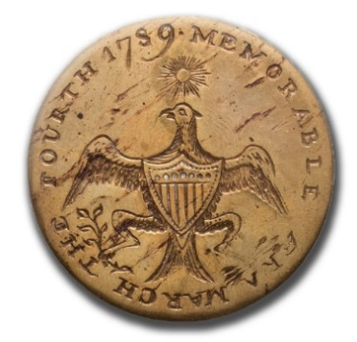
We offer here the largest known gathering from Washington’s own draft of his first inaugural address – his Manifesto on Government: In our first leaf, Washington recognizes the danger of hubris and does his honest best to share his sense of humility.

“shall I arrogantly pronounce that whosoever differs from me, must discern the subject through a distorting medium, or be influenced by some nefarious design? The mind is so formed in different persons as to contemplate the same object in different points of view. Hence originates the difference on questions of the greatest import, both human & divine.” (27)

Washington knew that the liberty Jefferson proclaimed could not exist in a vacuum. America needed Hamilton’s structure as well. Where others saw conflicting views and competing outcomes, Washington, a surveyor down to his core, forged a trail forward while leaving cautionary signs that we would still do well to heed.
“this Constitution, is really in its formation a government of the people… it is purely, a government of Laws made & executed by the fair substitutes of the people alone. The election of the differ^{t} branches of Congress by the Freemen, either directly or indirectly is the pivot on which turns the first wheel of government… At the same time the exercise of this right of election seems to be so regulated as to afford less opportunity for corruption & influence; & more for stability & system than has usually been incident to popular governments. Nor can the members of Congress exempt themselves from the consequences…” (28)

Today, Washington’s blind spots, particularly on slavery and the lack of rights for women and Native Americans, are so glaring that it can be hard for us to look away. Knowing what we know now, can we forgive his damning obliviousness to the irony of a slave-owner’s declamations on freedom?

“until the people of America shall have lost all virtue; until they shall have become totally insensible to the difference between freedom & slavery; until they shall have been reduced to such poverty of spirit as to be willing to sell that pre-eminent blessing, the birthright of Freemen, for a mess of pottage; in short, until they shall have been found incapable of governing themselves and ripe for a master - those consequences, I think, can never arrive” (35)

We cannot deny that he owned a full share of the nearly universal biases of his age. Still, his words and his actions played a pivotal role at the genesis of America’s long journey towards the ideals of the Declaration of Independence.
“it is time To advert to the system of policy, which ought, in my opinion, to be pursued to restore our public credit & secure our public felicity… My present object is to point out the means of encreasing & perpetuating the happiness of the people…” (35)
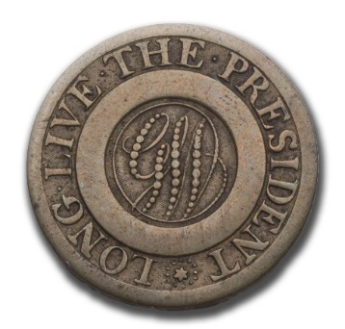
In an age of limited educational opportunity and avenues for the dissemination of information, and a strict demarcation between the governing and the governed, he showed innate flashes of forward-looking inclusiveness. He (dare I say he alone?) was capable of leading us to a path balanced between process and purpose.

“The preliminary observation that a free government ought to be built on the information and virtue of the people will here find its proper place. Happily our Citizens are remarkably instructed by education…& ingenious for making improvements…” (36)

Washington argues that the Constitution is imperfect but the best that could be crafted under the circumstances. He acknowledges that it could and should be amended to suit changing times and needs. However, he’s cautious about changing too much before it is given a chance to operate.

“I will barely suggest, whether it would not be the part of prudent men to observe it fully in movement, before they undertook to make such alterations, as might prevent a fair experiment of its effects?” (47)

In the mirror of history, it has been too easy to focus on Washington’s persona as the “Father of Our Country” without sufficiently crediting his cellular level grasp of political theory and structure.
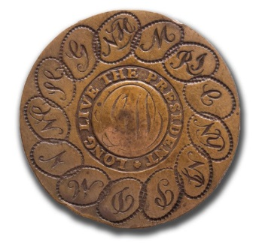
“I have a confident reliance, that your wisdom & patriotism will be exerted to raise the supplies for discharging the interest on the national debt & for supporting the government…in a manner as little burdensome to the people as possible…”(48)

------------------------------------------

Our Washington Manifesto Collection Includes:

- Three leaves (six pages) and three fragments written entirely by Washington. Only thirteen complete leaves, plus fragments, are known to survive. Seven are already in institutional collections; the other three are owned by separate collectors.

- An exceptionally fine collection of rare first inaugural buttons.

- A celebratory Washington parade sash – one of only two known to survive from the Founding Period.

- Washington’s Delivered First Inaugural Address, in a rare imprint, Boston’s Herald of Freedom and the Federal Advertiser.

This Collection, reuniting key parts of Washington’s most comprehensive political manifesto, is an intrinsic part of our heritage. It provides an intimate connection to our past, reminding us of the strength of ideals and actions that brought a people together to form a nation.

Whether for your personal and patriotic interest, or for your company, foundation, or favorite educational institution, please call me if you’d like to explore this opportunity to invest in history.

Seth Kaller

Authorship of Washington’s Inaugural Manifesto

From 1931-1939, the George Washington Bicentennial Commission published The Writings of George Washington from the Original Manuscript Sources. Earlier scholars such as Jared Sparks felt compelled to make (and to hide) editorial choices, and to dispose of controversial material. The Commission, however, appointed in part “to collect, collate, preserve, and publish writings, artworks, and photographs pertinent to [Washington’s] life and times,” would let the original letters and manuscripts speak for themselves. In Volume 30, following the text of the Delivered Address, the editors introduced Washington’s Draft “Proposed Address to Congress”:

This document now exists in fragmentary form only… it was discarded and not used. Jared Sparks, finding that the document had no official existence, did as he had done in other instances (especially the Washington “Diaries”), split up the document and presented pages and cuttings of pages to his friends.... It was most carefully written and evidently was considered of importance at the time it was inscribed. Some of the widely separated pages bear Sparks’ initialed statements that this is Washington’s handwriting, and on the margin of page 33 Sparks has written “Washington’s handwriting, but not his composition. J.S.” Comment is needless…

Jared Sparks (1789-1866), educated at Phillips Exeter Academy and Harvard, became the first pastor of the First Independent (later Unitarian) Church of Baltimore in 1817. He served as chaplain of the U.S. House of Representatives from 1821 to 1823, and contributed to the National Intelligencer and other periodicals. Leaving the ministry due to ill health, Sparks moved to Boston and in 1824 bought and began editing the North American Review. In 1827, he set out to gather, organize, edit, and publish George Washington’s correspondence. The resulting 12 volumes were published in 1834-1837 as The writings of George Washington: being his correspondence, addresses, messages, and other papers official and private, selected and published from the original manuscripts; with A life of the author, notes, and illustrations. (Boston: American Stationers Co., John B. Russell). While criticized by some for altering Washington’s text, it was generally well regarded and heavily used for decades.

Sparks’ prolific contributions to history include his 12-volume Diplomatic Correspondence of the American Revolution and 10-volume Works of Benjamin Franklin; with Notes and a Life of the Author. His discussions with Alexis de Tocqueville in 1831–1832, and extensive subsequent correspondence, helped inform the Frenchman’s famous Democracy in America. Having taught history, theology, natural philosophy, and mathematics, Sparks became the 17th President of Harvard College (now University) in 1849. His pioneering documentary collection of manuscripts and papers went to Harvard University, and his private library and maps were bought by Cornell University.

Sparks encountered what we call the Inaugural Manifesto in 1827, when he found it with three related letters. Washington had sent the first to James Madison on January 2, 1789, arranging delivery of a very confidential letter and enclosure. Washington mentioned this to Madison again on February 16th.

You have a rough draft only of the letter I had in contemplation to write to you… But having heard nothing from you since, I concluded that the intercourse between this and Orange [County] was not very regular although, ultimately it might be safe....

In a postscript, Washington gave Madison permission to discuss the matter with David Humphreys, a Washington aide, historian, and poet, who was then at Mount Vernon: “If it should be your own desire, I have not the smallest objection to your conversing freely with Col. H. on all matters respecting this business.”

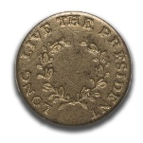
After getting the letters, reading the draft, and likely speaking with Humphreys, Madison entirely rewrote the speech. It was Madison’s version that Washington delivered on April 30, 1789, to a joint session of Congress.

Thirty-eight years later, Sparks wrote to Madison about his discovery of the letters and Washington’s manuscript.

The letter dated Jany. 1789, relates to the Message to the first Congress, and there is preserved with it the copy of a message, or, as he calls it, a speech, in his own hand, which I presume is the same that was sent to you for your revision… The person to whom he alludes as the author of it, and whom he designates as a “gentleman under this roof”, I suppose to be Colonel Humphreys. The speech, as copied by Washington, extends to seventy three pages… It is certainly an extraordinary production for a message to Congress, and it is happy, that Washington took counsel of his own understanding, and of his other friends, before he made use of this document. No part of it seems to have been formally introduced in the real message….

I hardly need ask your advice, as to the expediency of publishing in his works any allusion to this draft of a message, or his letter to you respecting it. I do not conceive that the public would derive benefit from them; but any observations from you on the subject will be thankfully received, and will have their due influence on my mind. The letter, which you wrote in reply, has not yet fallen into my hands.

Madison, who was proud of his role in writing the address that Washington delivered, readily accepted Sparks’ assertion that the lengthy draft was Humphreys’ radical and inferior composition. He replied to Sparks on May 30 that he concurred:

without hesitation, in your remarks on the speech of 73 pages, and in the expediency of not including it among the papers selected for the press. Nothing but an extreme delicacy towards the author of the Draft, who no doubt, was Col: Humphreys, can account for the respect shown to so strange a production.

Madison later added a note to the bottom of the Jan. 2 letter saying that the next letter from Washington,

being peculiarly confidential was returned or rather left with its enclosure, at Mt Vernon on my way to N. York. The return tho not asked nor probably expected, was suggested by a motive of delicacy.

Madison and Sparks understandably read Washington’s reference to mean that Humphreys was the author. We suggest another interpretation: the “gentleman under this roof” was Washington himself. By apparently disclaiming authorship, Washington cleverly signaled Madison that he could be as critical as necessary without having to take the president-elect’s feelings into account. The not untruthful diversion was effective, as we see from Madison’s willingness to rewrite it entirely. The result was a Delivered Inaugural that was absolutely more appropriate for the occasion.

Humphreys never claimed authorship of the undelivered draft, but one piece of evidence has supported the attribution. Four months after the inauguration, he gave a Fourth of July oration to Connecticut’s Society of the Cincinnati branch. Nearly all of that speech was recycled from the inaugural draft, though rewritten in the third person. While Sparks took that as confirmation of Humphreys’ authorship, scholar W. B. Allen notes that the differences between the draft and Humphreys’ oration bolster his “confidence that the ‘discarded inaugural’ reflects Washington’s own thoughts.” The draft address is not only in Washington’s hand, but also in his voice, finding “echoes of its ideas throughout Washington’s correspondence.”

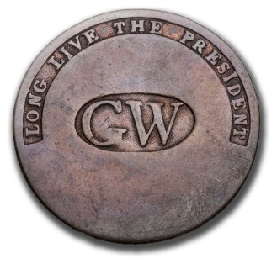
The writing is one compelling reason to take issue with Sparks’ assertion that the manuscript was merely “copied by Washington.” Every known surviving part of the original “discarded draft” is in Washington’s own hand, except for marginal identifications added later by Sparks. Would the extremely busy president-elect be content to act as a scribe, rewriting someone else’s 73-page manuscript? It is impossible to imagine him playing such an impersonal, time consuming and menial role on a document he clearly considered of great importance.

Even more compelling is the fact that the ideas, vocabulary, and style align perfectly with Washington’s other writings. While Humphreys likely wrote an initial draft, the fact that the content captures Washington’s voice so well demonstrates that he must have had a significant hand in authoring the final “discarded draft.”

Washington had long advocated for a stronger federal government and had served as president of the Constitutional Convention. His reaction to the internal strife (Shays’ Rebellion, for example), commercial vulnerability, and international humiliation that characterized the plight of the nation under the Articles of Confederation is reflected in the Manifesto. Only the ignorant, the wicked, or the well-meaning but uninformed could have ignored the crisis, he thought. The beliefs spelled out in this Manifesto were strongly held and of great personal significance.

With access to resources that Sparks could not have dreamed of, we see that Washington was the better writer. Humphreys’ poetry and prose is dated, while much of what Washington wrote about the need to bolster America’s government during the Revolution, as well as in the immediate aftermath of the Constitutional Convention and during the process of ratification, is easy to read and incredibly relevant today.

But, as much as Washington might have wanted to express what he had written in his Manifesto, at that fragile moment, it was wiser not to say anything that could distract from the work at hand. This wasn’t the time to rehash controversial debates and risk giving anti-Federalists new ammunition.
We need borrow only four words from a modern work of genius to perfectly summarize the advice that Madison gave: “talk less, smile more.”

Washington heeded the message. The entire Delivered Speech can be read on pages 34-36. We think this excerpt is telling in all that it doesn’t tell:

By the article establishing the Executive Department, it is made the duty of the President “to recommend to your consideration, such measures as he shall judge necessary and expedient.” The circumstances under which I now meet you, will acquit me from entering into that subject, farther than to refer to the Great Constitutional Charter under which you are assembled; and which, in defining your powers, designates the objects to which your attention is to be given. It will be more consistent with those circumstances, and far more congenial with the feelings which actuate me, to substitute, in place of a recommendation of particular measures, the tribute that is due to the talents, the rectitude, and the patriotism which adorn the characters selected to devise and adopt them.

As opposed to the Delivered Address, this draft – our Manifesto – gives a detailed, nuanced, and complete picture of Washington’s thoughts for the nation he was about to lead. What survives of the manuscript, Allen argues, makes “a manifest contribution to our knowledge of how far Washington’s understanding, as opposed to his image, contributed to the founding of the United States.”
This Manifesto provides the most comprehensive statement of Washington’s political acumen, and his vision for America. Here, we see the possibilities that Washington envisioned for America. Perhaps looking back can help light us to a better way forward.

Private Ownership and Opportunity

Though few nations are blessed with surviving founding records of similar importance, America’s Founding and early Presidential papers are widely scattered. How can such history be privately owned? Most of America’s institutions started with personal collections; even the Library of Congress began with the acquisition of Jefferson’s private library. It wasn’t until Richard Nixon’s papers were contentiously sold that Congress established the National Archives system to own and administer new presidential archives.

Visionary individual and institutional donors have always played a significant role in preserving America’s history. Thanks to the Mount Vernon Ladies Association, the Donald W. Reynolds Foundation, David M. Rubenstein, and other generous donors, The Fred W. Smith Library for the Study of George Washington opened in 2013 on the grounds of Mount Vernon. (The Washington Presidential Library does not have any of the leaves or fragments from the first inaugural.) Efforts are currently underway to revitalize similarly relevant institutions, particularly New York’s Federal Hall, where Washington was inaugurated as President and delivered the First Inaugural Address.

Our Collection Offering of Inaugural Leaves & Fragments
Over the decades that Sparks worked on Washington’s biography, he was besieged by autograph and souvenir seekers. Thinking that there was no merit in retaining the draft inaugural address among the papers, he began to give away pages -- a decision that has been criticized by historians ever since. Later, as his supply ran low, he started cutting the pages apart into smaller and smaller fragments. This section contains the images and transcripts only of the parts that are offered here. A reconstructed transcript, including all content known from any sources, follows, beginning on page 24.

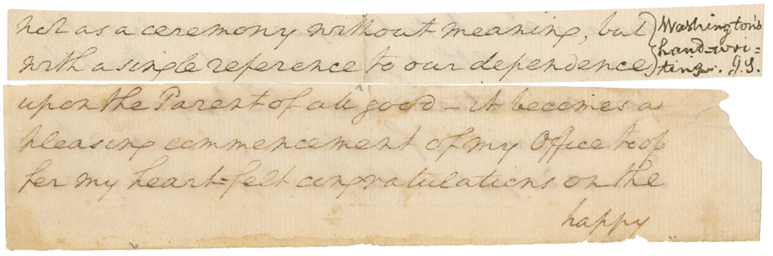
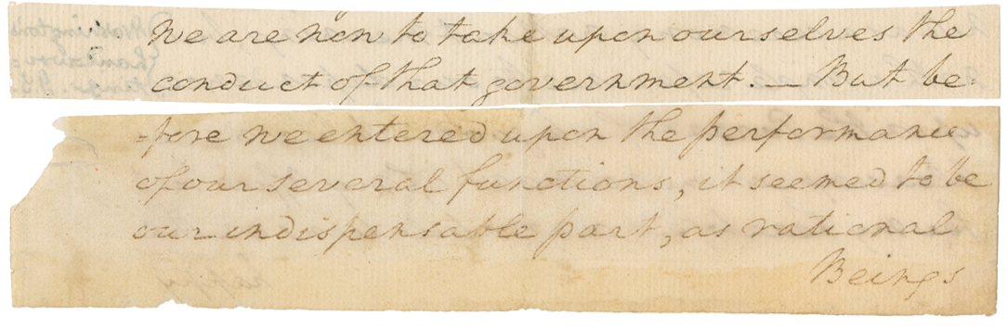

[We are this day assembled on a solemn and important occasion…]
not as a ceremony without meaning, but
with a single reference to our dependence/ *

upon the Parent of all good—it becomes
a pleasing commencement of my Office to offer
my heart-felt congratulations on the happy

* [Added by Sparks: “Washington’s handwriting. J.S.”]

We are now to take upon ourselves the
conduct of that government. But be/

fore we entered upon the performance
of our several functions, it seemed to be
our indispensable part, as rational
Beings

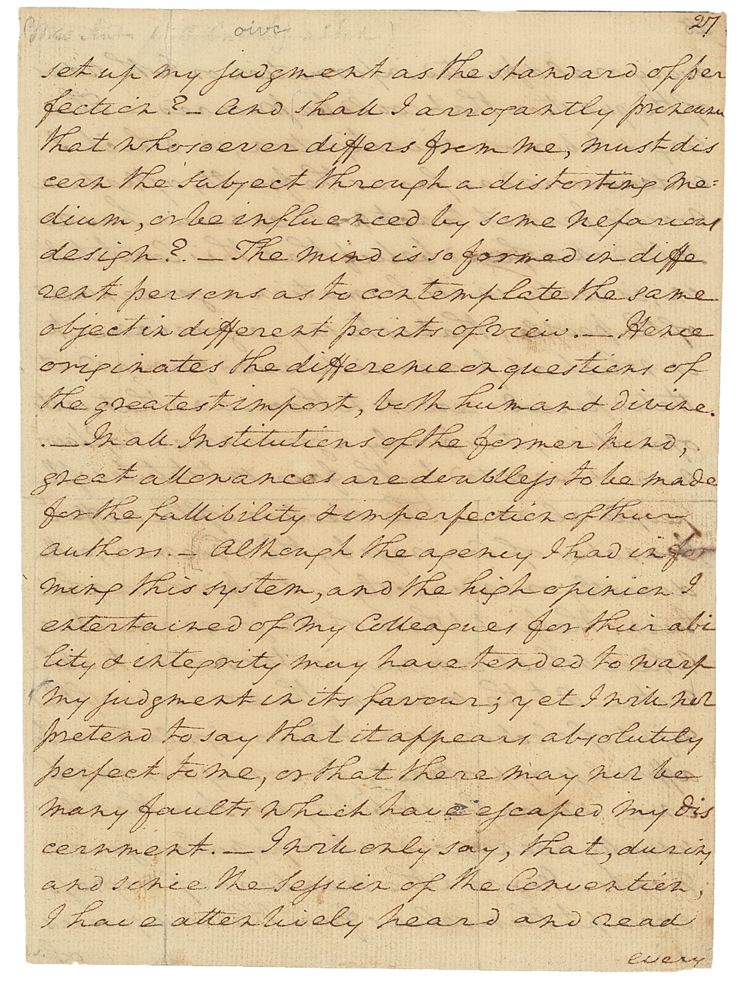
27

set up my judgment as the standard of perfection?
And shall I arrogantly pronounce
that whosoever differs from me, must discern
the subject through a distorting medium,
or be influenced by some nefarious
design? The mind is so formed in different
persons as to contemplate the same
object in different points of view. Hence
originates the difference on questions of
the greatest import, both human & divine.
In all Institutions of the former kind,
great allowances are doubtless to be made
for the fallibility & imperfection of their
authors. Although the agency I had in forming
this system, and the high opinion I
entertained of my Colleagues for their ability &
integrity may have tended to warp
my judgment in its favour; yet I will not
pretend to say that it appears absolutely
perfect to me, or that there may not be
many faults which have escaped my discernment.
I will only say, that, during
and since the Session of the Convention,
I have attentively heard and read
every

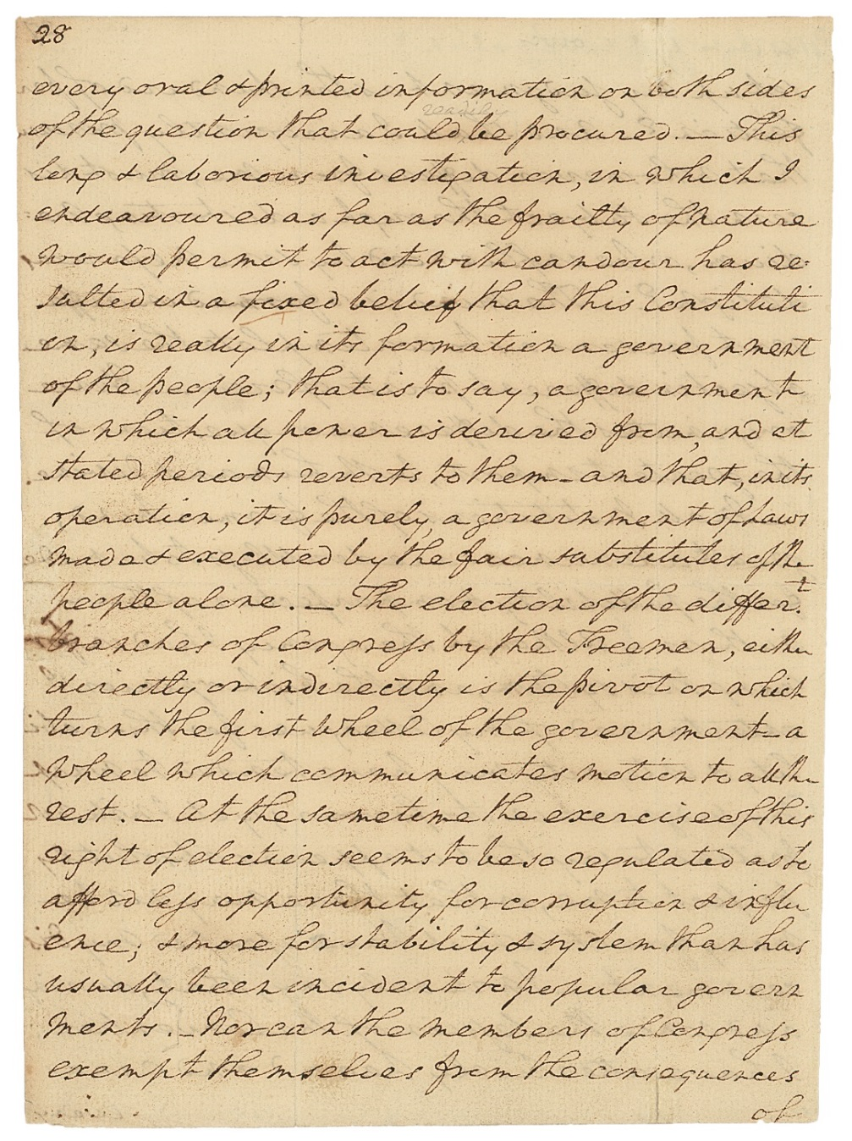
28

every oral & printed information on both sides
of the question that could be procured. This
long & laborious investigation, in which I
endeavoured as far as the frailty of nature
would permit to act with candour has resulted
in a fixed belief that this Constitution,
is really in its formation a government
of the people; that is to say, a government
in which all power is derived from, and at
stated periods reverts to them--and that, in its
operation, it is purely, a government of Laws
made & executed by the fair substitutes of the
people alone. The election of the differ^{t}
branches of Congress by the Freemen, either
directly or indirectly is the pivot on which
turns the first wheel of the government--a
wheel which communicates motion to all the
rest. At the same time the exercise of this
right of election seems to be so regulated as to
afford less opportunity for corruption & influence;
& more for stability & system than has
usually been incident to popular governments.
Nor can the members of Congress
exempt themselves from the consequences
of

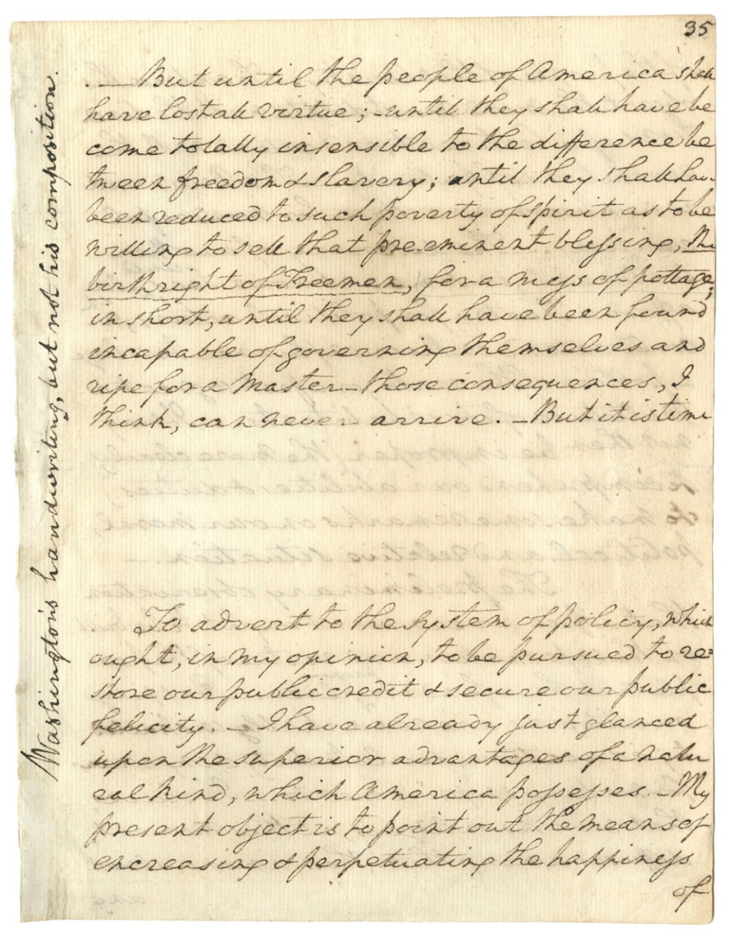
35

But until the people of America shall
have lost all virtue; until they shall have become
totally insensible to the difference between
freedom & slavery; until they shall have
been reduced to such poverty of spirit as to be
willing to sell that pre-eminent blessing, the
birthright of Freemen, for a mess of pottage;
in short, until they shall have been found
incapable of governing themselves and
ripe for a master - those consequences, I
think, can never arrive. But it is time

To advert to the system of policy, which
ought, in my opinion, to be pursued to restore
our public credit & secure our public
felicity. I have already just glanced
upon the superior advantages of a natural
kind, which America possesses. My
present object is to point out the means of
encreasing & perpetuating the happiness
of

[Written vertically, in Jared Sparks’ hand:
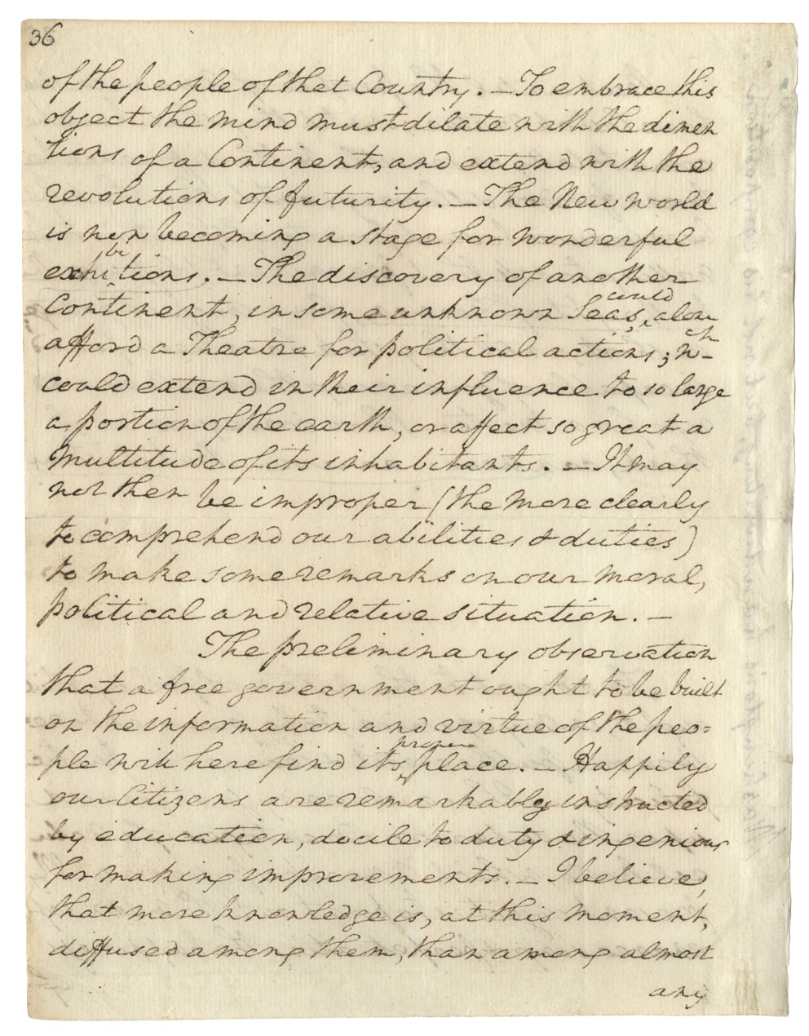
“Washington’s handwriting, but not his composition.”]
36

of the people of that Country. To embrace this
object the mind must dilate with the dimentions
of a Continent, and extend with the
revolutions of futurity. The New world
is now becoming a stage for wonderful
exhibitions. The discovery of another
Continent, in some unknown Seas, could alone
afford a Theatre for political actions; wch
could extend in their influence to so large
a portion of the earth, or affect so great a
multitude of its inhabitants. It may
not then be improper (the more clearly
to comprehend our abilities & duties)
to make some remarks on our moral,
political and relative situation.
The preliminary observation
that a free government ought to be built
on the information and virtue of the people
will here find its proper place. Happily
our Citizens are remarkably instructed
by education, docile to duty & ingenious
for making improvements. I believe,
that more knowledge is, at this moment,
diffused among them, than among almost
any

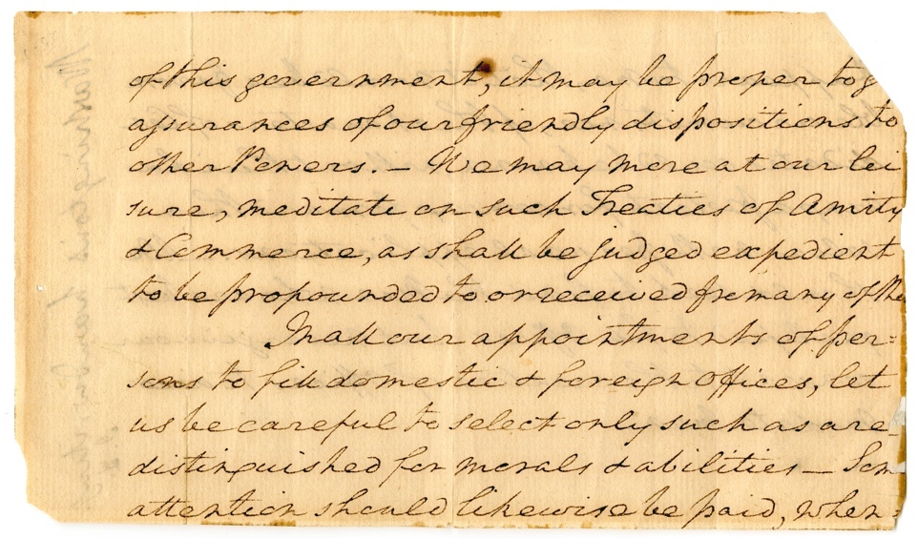

[45] [top of page only]

of this government, it may be proper to give assurances of our friendly dispositions to other Powers. We may more at our leisure, meditate on such Treaties of Amity & Commerce, as shall be judged expedient to be propounded to or received from any of the<m.> In all our appointments of persons to fill domestic & foreign offices, let us be careful to select only such as are distinguished for morals & abilities--Som<e> attention should likewise be paid, when …

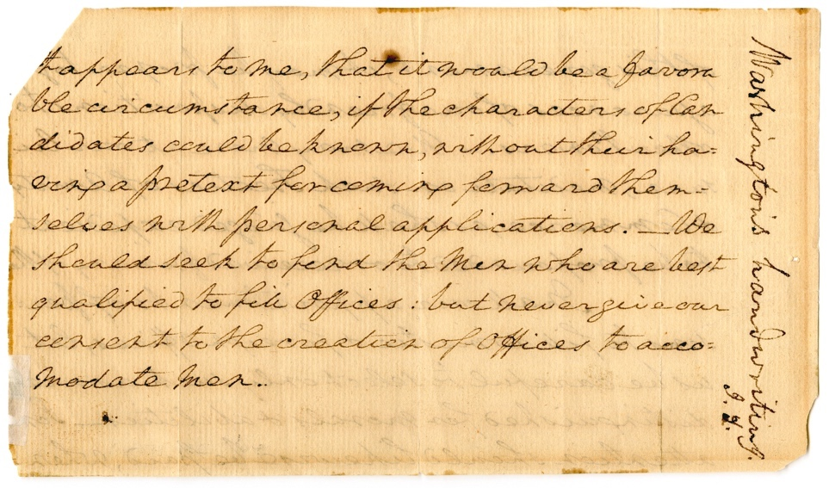

[46] [top of page only]

It appears to me, that it would be a favorable circumstance, if the characters of Candidates could be known, without their having a pretext for coming forward themselves with personal applications. We should seek to find the Men who are best qualified to fill Offices: but never give our consent to the creation of Offices to accomodate men.

[Written vertically, in Jared Sparks’ hand:
“Washington’s handwriting. J.S.”]

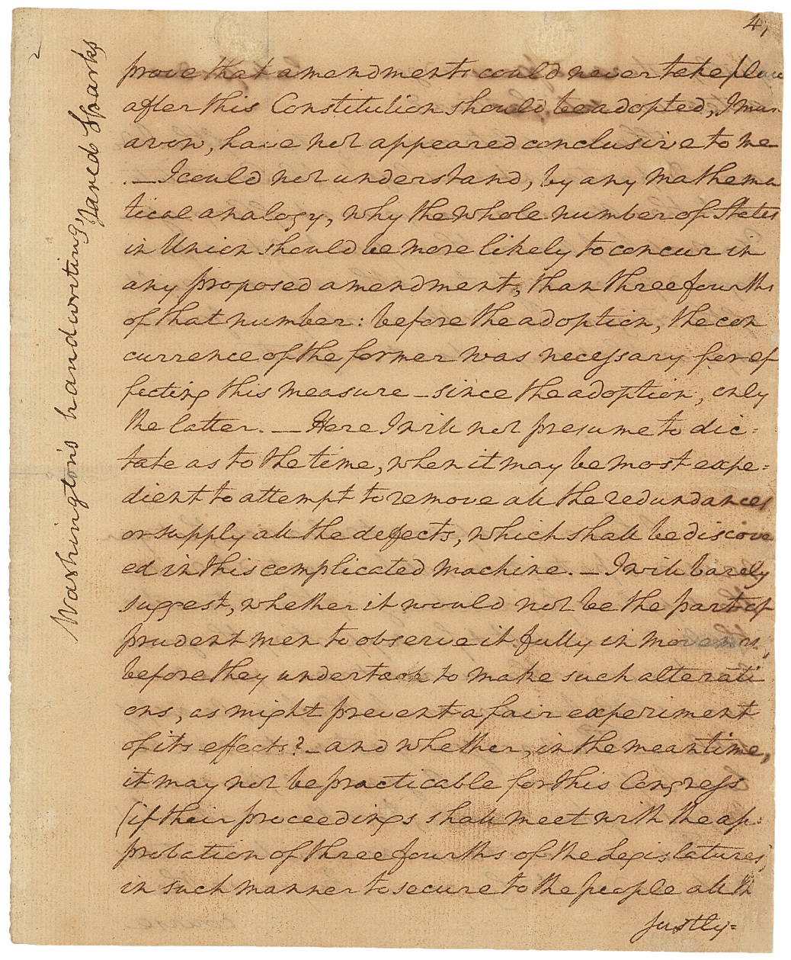
47
[The reasoning which have been used, to]
prove that amendments could never take place
after this Constitution should be adopted, I must
avow, have not appeared conclusive to me.
I could not understand, by any mathematical
analogy, why the whole number of States
in Union should be more likely to concur in
any proposed amendment, than three fourths
of that number: before the adoption, the con
currence of the former was necessary for effecting
this measure--since the adoption, only
the latter. Here I will not presume to dictate
as to the time, when it may be most expedient
to attempt to remove all the redundances
or supply all the defects, which shall be discovered
in this complicated machine. I will barely
suggest, whether it would not be the part of
prudent men to observe it fully in movement,
before they undertook to make such alterations,
as might prevent a fair experiment
of its effects?--and whether, in the meantime,
it may not be practicable for this Congress
(if their proceedings shall meet with the approbation
of three fourths of the Legislatures)
in such manner to secure to the people all their
justly

[Written vertically, in Jared Sparks’ hand:
“Washington’s handwriting, Jared Sparks”]
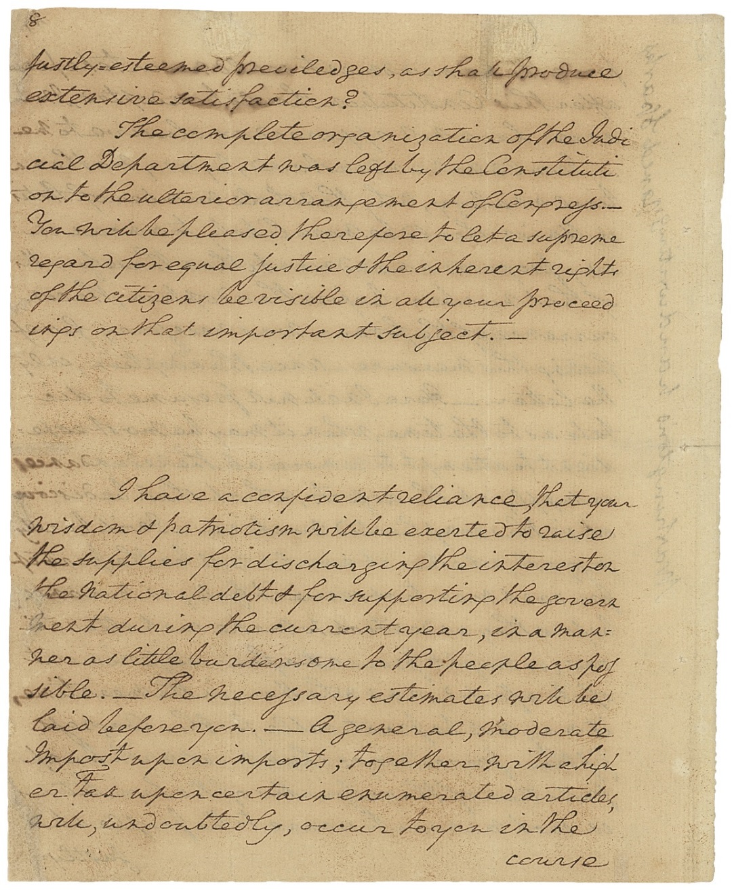
48

justly esteemed previledges, as shall produce
extensive satisfaction?
The complete organization of the Judicial
Department was left by the Constitution
to the ulterior arrangement of Congress.
You will be pleased therefore to let a supreme
regard for equal justice & the inherent rights
of the citizens be visible in all your proceedings
on that important subject.

I have a confident reliance, that your
wisdom & patriotism will be exerted to raise
the supplies for discharging the interest on
the national debt & for supporting the government
during the current year, in a manner
as little burdensome to the people as possible.
The necessary estimates will be
laid before you. A general, moderate
Impost upon imports; together with a higher
tax upon certain enumerated articles,
will, undoubtedly, occur to you in the
course

Provenance:
All start with George Washington, to James Madison, returned to George Washington, to Bushrod Washington, to Jared Sparks, and then

Pages 27-28 and 47-48.
Frederick S. Peck, sold Samuel T. Freeman & Co, February 17, 1947, lot 186 (with pages 57-62); Forrest G. Sweet, Parke-Bernet, May 8, 1957, lot 370 (with pages 19-20 and 57-62); Nathaniel E. Stein, sold Sotheby Parke Bernet, January 30, 1979, lot 183 and 187; Fred Nederlander, Sotheby’s, June 19, 2015, lot 144 and 145; present owner.

Pages 35-36.
Mary Lyell, sold Phillips, June 13, 1996, lot 225; private collector, sold Christie’s, November 13, 2011, lot 204; present owner.
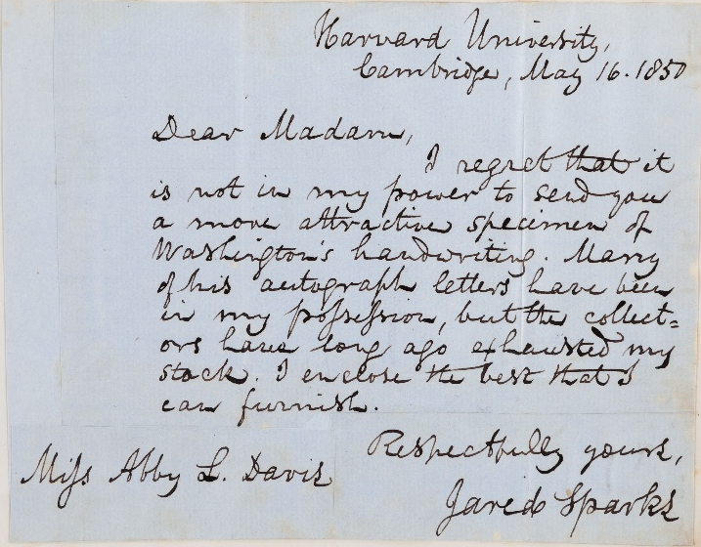
Fragment “BC”.
Jared Sparks Autograph Letter Signed, May 16, 1850, to Miss Abby L. Davis: “I regret that it is not in my power to send you a more attractive specimen of Washington’s handwriting. Many of his autograph letters have been in my possession, but the collectors have long ago exhausted my stock. I enclose the best that I can furnish.” Sotheby’s April 26, 1978 (Sang), lot 295. Duane N. Diedrich (1983), Muncie, Ind.

Fragment “AB”.
Jared Sparks. Autograph Letter Signed, February 20, 1857, to Rev. Smith: “I regret that I cannot furnish you with any autographs that will be interesting to your friend. I have had many, but the collectors have exhausted my stock. I enclose a scrap of Washington’s hand-writing, but am unable to supply a signature…”. Col. Ray Trautman, 1958. Stein, lot 180. Robert F. Batchelder catalog 19, item 104.
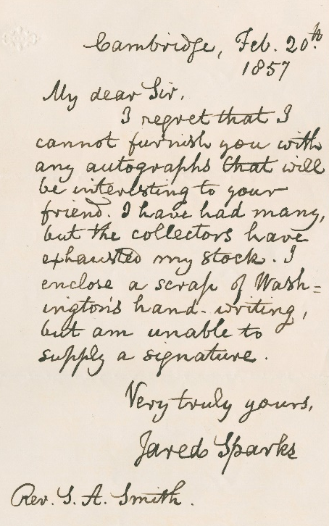
Top page 45–46. Sotheby Parke Bernet (Stein), January 30, 1979, lot 186; Justin Turner; Joseph Rubinfine, list 153, 2005, #2; Sotheby’s January 27, 2020, lot 2164.

Census of Known Complete Leaves

The 1947 Peck Collection auction at Freemans had the largest known grouping at the time, to which two leaves (pp 19-20 and 47-48) were added before the 1957 Sweet Collection sale at Parke-Bernet. Another leaf was discovered between then and the 1979 Nathaniel Stein auction at Sotheby’s (either pp 39-40 or 41-42; an error makes it unclear). All are located on our census. We have not found that any additional pages have been discovered since 1979, nor do we know whether the unlocated pages were penned by Washington, as all of these were.

5-6 Princeton University Library, De Coppet Collection. Resources of America in Struggle for Independence, & resulting
debt.

19-20 Private. Denying “dynastic ambitions” and desire for power

23-24 Princeton University Library, De Coppet Collection.
Expansion across the continent; America’s shining light for the world; “mankind will…not continue slaves in one part of the globe, when they can become freemen in another.”

27-28 The Constitution as “a government of the people.”

29-30 Pierpont Morgan Library. The merits of the new government under the Constitution. “no government before …”

33-34 Massachusetts Historical Society. “no compact among men (however provident in its construction & sacred in its ratification) can be pronounced everlasting and inviolable.”
35-36 “the difference between freedom & slavery…the birthright of Freemen….a free government out [sic] to be built on the information and virtue of the people…”

[39-40] or [41-42] Gilder Lehrman Collection 00639.25. Foreign relations, American trade, manufactures & defense. (Stein had marked as 36-37.)

47-48 Three-fourths vs. unanimous state approval for amendments; the Judicial Dept. & “a supreme regard for equal justice & the inherent rights of the citizens;” “discharging the interest on the national debt;” & taxes & duties.

49-50 Gilder Lehrman Collection 04443.01. Taxation & the national debt. No government “introduced among mankind ever contained so many checks & such efficatious restraints to prevent it from degenerating into any species of oppression.”

57-58 Gilder Lehrman Collection 01589. Trade & population growth, with allusion to postal service, newspapers & manufactures.

59-60 Private. National resources & developing the country.

61-62 Private. Urging Congress to “take measures for promoting the general welfare.”

Original 1789 First Inaugural Buttons

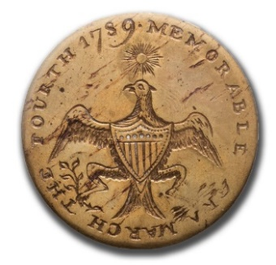
1. “Memorable Era / March the Fourth 1789” Splayed eagle design brass coat button. Similar to what Washington himself wore at the inauguration. 34 mm. brass. One of the finest extant.
March 4th was the day appointed for the first meeting of the first Federal Congress.

2. Linked Chain of States
The most popular of Washington buttons. One of the finest struck originals extant. The lip of the hand-made planchette (the metal disc) curled a little at bottom, but that helps confirm authenticity (a centennial re-strike used the same original die, but on flat machine-made planchettes). 34 mm.

3. "Dotted Script" GW inside block “Long Live the President
Very rare design variant. 35 mm.


4. “Long Live the President” Extremely rare variant design.
33 mm.

5. Long Live the President / GW
The most common, though popular, design. 34 mm.

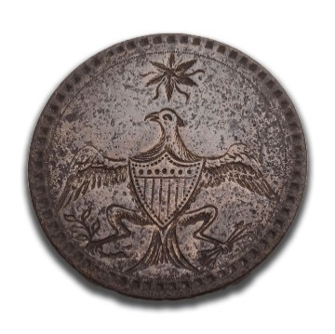
6. Splayed Eagle Under Star
A more common variety, in very good condition. 34 mm.

7. “Long Live the President”
Small George Washington button. 15 mm.

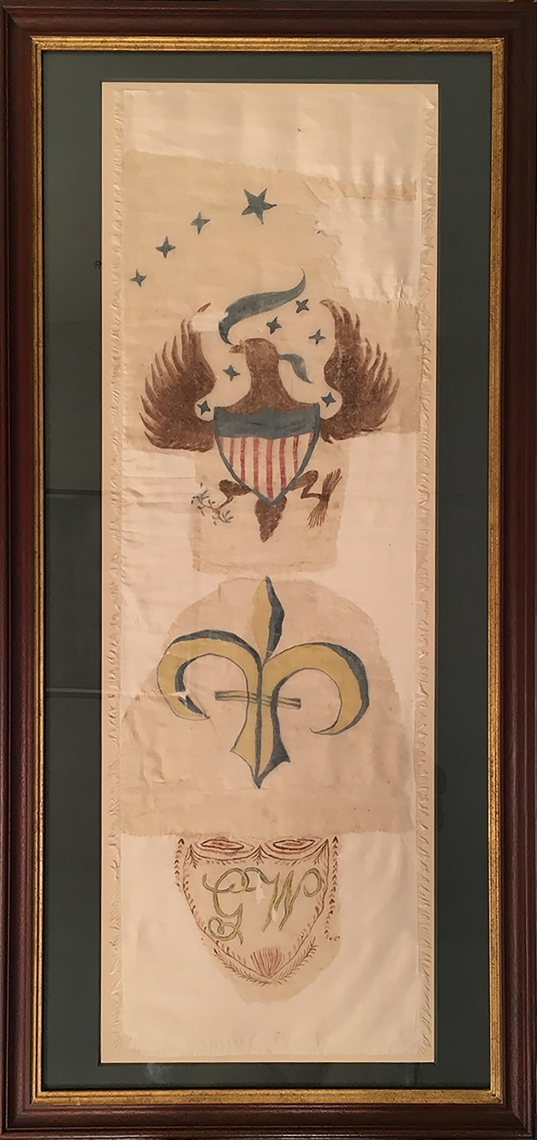
Original George Washington Parade Sash

In addition to metal clothing buttons, contemporaries also produced various textiles by hand, or printed in extremely limited quantities. These were worn primarily by women as personal adornments during the inauguration and in celebration of Washington’s travels early in his presidency.

This sash is composed of three fragments with original design elements attached to a modern 10ʺ x 32ʺ support fabric. The fragments are made of coarsely spun silk with separate painted designs. These designs consist of an American eagle surrounded by thirteen stars (three are lost but can be extrapolated based on the symmetry of design, and there isn’t a place for a fourteenth star, which would have been added after the admission of Vermont in 1791), followed by a fleur-de-lis, and a shield with floral elements and the monogrammed initials GW.

Alphaeus H. Albert, an early and preeminent authority on Washington inaugural artifacts, describes such textiles in his 1949 work Washington Historical Buttons: “An account in the Massachusetts Centinel from 1789, makes mention that ‘The women not to be outdone by the men agreed to adopt an article of attire to be worn as a testimonial to the illustrious President. They invented a sash, a broad white ribbon, with “GW” in gold letters or spangles, encircled by a laurel wreath in front - on one end of the sash to be painted the American eagle, and on the other a Fleur-de-lis.’

“In the late autumn of 1789, the President made a ‘good will’ tour and this same Massachusetts newspaper carried an advertisement for many days to the effect that: ‘A few elegant Washington sashes and Ribbons were taken in. Printed in Gild in the neatest manner.’…”

The ‘chicken eagle’ dates to the Federal period. It appears on the title pages of almanacs from the 1780s and 1790s as well as Liverpool jugs exported to America.

The fleur-de-lis, a heraldic devise of great antiquity, was long associated with the rulers of France. Considering the crucial role France played in the American Revolution, it was appropriate for this symbol to be associated with America’s first President. However, once the French revolution that started in 1789 gathered steam and became more radical and bloody, tensions between the two countries quickly grew, and symbols of French and American cooperation quickly lost favor. After the overthrow of the French monarchy in 1792, the new government started to export her revolution by going to war with Britain and much of the rest of Europe. Rather than supporting our former ally, Washington proclaimed American neutrality. By the end of his second term, an undeclared naval war was well underway, and many were expecting outright war, which very nearly came during John Adams’ administration. The “GW” monogram appeared on period inaugural buttons and in newspapers and pamphlets, as well as items in this collection

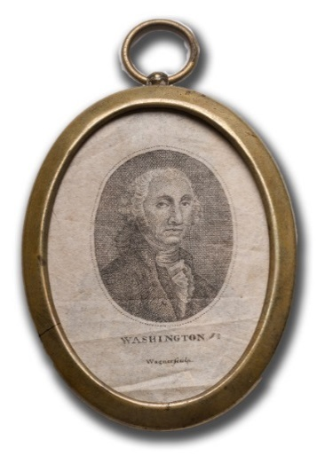
Also in the Collection:
Miniature print of
George Washington, in locket,
by “Wagner / sculpt,”
ca. 1801-1805.
45 x 35 mm.

Washington’s Delivered Address
on Front Page of Boston’s
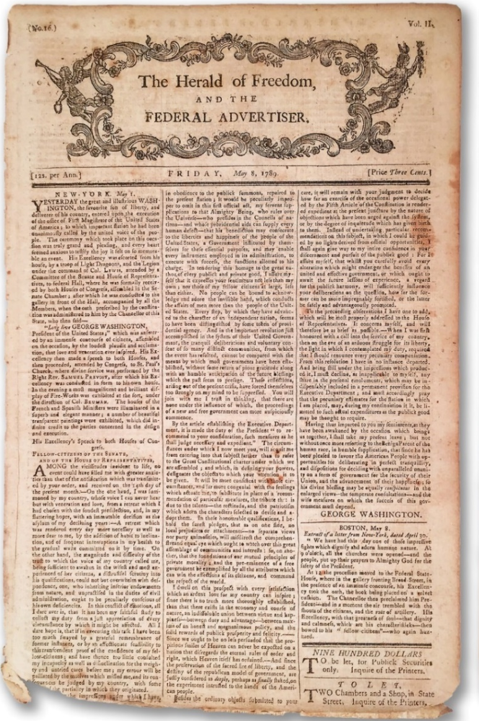
Herald of Freedom and the Federal Advertiser, May 8, 1789

Historic Background: The First Inaugural Ceremony

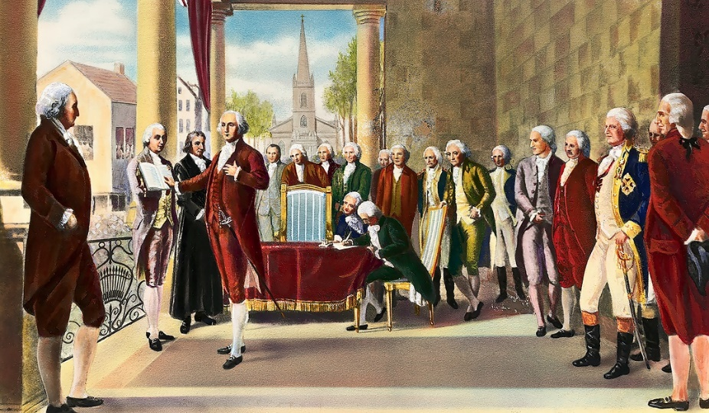

On the morning of April 30, crowds began to gather in front of the presidential mansion. According to the diary of Tobias Lear, Washington’s personal secretary:

At nine o’clock all the churches in the city were opened, and prayers offered up to the Great Ruler of the universe for the preservation of the President.…At half past twelve the procession moved forward, the troops marching in front with all the ensigns of military parade. Next came the committees and heads of departments in their carriages. Next the President in the state coach, and Colonel Humphreys and myself in the President’s own carriage. The foreign ministers and a long train of citizens brought up the rear.
About two hundred yards before we reached the hall, we descended from our carriages, and passed through the troops, who were drawn up on each side, into the Hall and Senate-chamber, where we found the Vice-President, the Senate, and House of Representatives assembled. They received the President in the most respectful manner, and the Vice-President conducted him to a spacious and elevated seat at the head of the room. A solemn silence prevailed. The Vice-President soon arose and informed the President, that all things were prepared to administer the oath whenever he should see fit to proceed to the balcony and receive it. He immediately descended from his seat, and advanced through the middle door of the Hall to the balcony. The others passed through the doors on each side. The oath was administered in public by Chancellor

Livingston; and, the moment the chancellor proclaimed him President of the United States, the air was rent by repeated shouts and huzzas,--‘God bless our Washington! Long live our beloved President!’ We again returned into the Hall, where, being seated as before for a few moments, the President arouse and addressed the two branches of Congress in a speech, which was heard with eager and marked attention.

Fisher Ames “sat entranced,” writing

It was a very touching scene, and quite of the solemn kind. His aspect grave, almost to sadness; his modesty, actually shaking; his voice deep, a little tremulous, and so low as to call for close attention.
On the other hand, William Maclay gave a rare critical account:

This great man was agitated and embarrassed more than ever he was by the leveled cannon or pointed musket. He trembled, and several times could scarce make out to read, though it must be supposed he had often read it before…. When he came to the words [“]all the world,[”] he made a flourish with his right hand, which left rather an ungainly impression. I sincerely, for my part, wished all set ceremony in the hands of the dancing-masters, and that this first of men had read off his address in the plainest manner…for I felt hurt that he was not first in everything.

Following the address the president and the members of the House and Senate walked about seven hundred yards to St. Paul’s Chapel to attend services conducted by the Rev. Dr. Samuel Provoost, bishop of the Episcopal church of New York and rector of Trinity Church. Prayers were offered and a Te Deum sung, and after the services Washington retired to the presidential mansion. He apparently dined quietly at home; then as Lear noted in his diary, “the President, Colonel Humphreys, and myself went in the beginning of the evening in the carriages to Chancellor Livingston’s and General Knox’s, where we had a full view of the fire-works.”

On his way to Livingston’s, Washington halted to admire the house of the French minister, the comte de Moustier,

illuminated and decorated with several transparencies relative to the victories and virtues of General Washington. He seemed pleased with the one representing eleven bees emerging from their hives, headed by their queen, with an epigraph from Virgil.

Don Diego de Gardoqui reported to the Spanish minister of State that he had decorated his house

with two magnificent transparent gardens, adorned with statues, natural size, imitating marble…. There were also various flower-pots, different arches with foliage and columns of imitation marble, and on the sky of these gardens were placed thirteen stars, representing the United States of America--two of which stars showed opaque, to designate the two States which had not adopted the Constitution.

Washington and his party returned to the presidential residence about ten o’clock in the evening, traveling on foot because the crowds thronging the streets were too great to permit the passage of carriages.
Text of All Known Parts of Washington’s Inaugural Manifesto

The transcript below is based primarily on The Papers of George Washington, Presidential Series. We have edited and supplied additional information whenever possible, and added locations of the copies in institutional collections and the last known sale or location of privately held examples.

The text in red is part of the Collection offered here.

David Humphreys clearly assisted George Washington in writing a prior, now lost, draft. The text in light blue appears in David Humphreys’ Oration on the Political Situation of the United States of America in the Year 1789. We infer that this text, perhaps with minor variations, was also in Washington’s draft.

Unbracketed page numbers were penned by Washington. The numbers in brackets are conjectural, in as logical order as possible. In some cases, particularly with smaller fragments, we may not know which side is front or back, and there are a few for which we only have the text of one side or less, taken from an old auction catalog or photocopy in the Papers of George Washington.

While recipients of the leaves and fragments were told that they had something written by Washington, the connection to the inaugural address was often lost. We have helped to identify a couple fragments as having come from the address; they are included.

-------------------------------------------------------------------
[1] We are this day assembled on a solemn and important occasion— [1974, Stein]

[1–2] not as a ceremony without meaning, but with a single reference to our dependence

[1-2] upon the Parent of all good—it becomes a pleasing commencement of my Office to offer my heart-felt congratulations on the happy [Seth Kaller, Inc., K#24818.04]

[1–3] We are now to take upon ourselves the conduct of that government. But be

[1 –3] -fore we entered upon the performance of our several functions, it seemed to be our indispensable part, as rational Beings [K#24818.06]

[1–4] fairs. It will doubtless be conceded [verso (?); privately owned (1958), photocopy from Stein]

[1–4] been happily diffused & fostered among ⟨their⟩ [recto (?); private, GWP from Stein]

[1–4] reputation and a decent respect for the sentiments of others, require that something should be said by way of apology for my

5 At the beginning of the late War with Great Britain, when we thought our selves justifiable in resisting to blood, it was known to those best acquainted with the different condition of the combatants & the probable cost of the prize in dispute, that the expence in comparison with our circumstances as Colonists must be enormous--the struggle protracted, dubious & severe. It was known that the resources of Britain were, in a manner, inexhaustible, that her fleets covered the Ocean, and that her troops had harvested laurels in every quarter of the globe. Not then organised as a nation, or known as a people upon the earth--we had no preparation--Money, the nerve of War, was wanting. The Sword was to be forged on the Anvil of necessity: the treasury to be created from nothing. If we had a secret resource of an nature unknown to our enemy, it was in the unconquerable resolution of our Citizens, the conscious rectitude of our cause, and a confident trust that we should not be forsaken by Heaven. The people willingly

6 offered themselves to the battle; but the means of arming, clothing & subsisting them; as well as of procuring the implements of hositlity were only to be found in anticipations of our future wealth. Paper bills of credit were emitted: monies borrowed for the most pressing emergencies: and our brave tr[oo]ps in the field unpaid for their services. In this manner, Peace, attended with every circumstance that could gratify our reasonable desires, or even inflate us with ideas of national importance, was at length obtained. But a load of debt was left upon us. The fluctuations of and speculations in our paper currency, had, but in too many instances, occasioned vague ideas of property, generated licencious appetites & corrupted the morals of men. To these immediate consequences of a fluctuating medium of commerce, may be joined a tide of circumstances that flowed together from sources mostly opened during and after the war. The ravage of farms, the conflagration of towns, the diminution [Princeton University Library, De Coppet Collection] of agriculture, the extinction of trade, the embarrassment of some who were indebted to British merchants before the war, the privation in all, during its continuance, of many conveniences of life, the subsequent influx of merchandize, the tempting facility of procuring it without present payment, the growing taste for extravagance, and the habit, too soon acquired, of deferring or eluding satisfaction for just obligations, now began to overwhelm the continent with private distress, bankruptcy and breach of faith.

[7-14] [recto, end of page] From this period also our public affairs were seen to decline. I will ask your patience for a moment, while I speak on so unpleasant a subject as the rotten part of our old Constitution. It is not a matter for wonder that the first projected plan of a foederal government, formed on the defective models of some foreign Confederacies, in the midst of a war, before we had much experience; and while, from the concurrence of external danger and the patriotic impulse of the moment, implicit obedience was yielded to the requisitions of an advisory council, should have been imperfect. Our astonishment ought rather to be excited, that, feeble and inefficient as the government was, it not only carried us in safety through the war, but kept us from severance until another could be substituted. By the original confederation, the right to make demands on the several states for such pecuniary supplies as might be necessary for defraying the expenses of the war, and for supporting the government of the Union, together with some other specific prerogatives of sovereignty, were committed to Congress.

[7-14] [verso, end of page] But Congress, constituted in most respects as a diplomatic body, possessed no power of carrying into execution a simple Ordinance, however strongly dictated by prudence, policy or justice. The individual States, knowing there existed no power of coertion, treated with neglect, whenever it suited their convenience or caprice, the most salutary measures of the most indispensable requisitions of Congress. Experience taught us, that the powers given by the members of the union to their federal head, were not sufficient to enable it to accomplish the purposes for which the body politic had been formed. We now touched on the hour of humiliation. The confederacy was found to be a government in name, rather than in reality.

[7-14] [recto, end of page] name a bye-word on the earth. Hence we were exposed to insurrection at home, and contempt abroad. Hence there were nations, which, in some measure excluded our Vessels from their Ports, checked our Commerce by [K#23154] intolerable impositions, introduced its ships into our carrying trade, and, because we were destitute of a retaliating power, refused to enter into a commercial treaty with us.

[7-14] [verso, end of page] The veil that concealed this melancholy and afflicting picture was at last withdrawn. The wise and the good stood astonished at the sight, none but the ignorant or wicked rested unconcerned. Even fearfulness siezed, in many instances, upon those well-meaning politicians, whose security had been produced by the Scantiness of their information & the confinement [K#23154] of their views to the local advantages of the states to which they belonged.

[7-14?] Justice & unanimity in those states [Stein, lot 184, not in GWP]

[15] [recto] …situation could be so agreeable to me as the condition of a private citizen. I solemnly assert and appeal to the searcher of hearts to witness the truth of it, that my leaving home to take upon myself the execution of this Office was the greatest personal sa [Private. GWP]
crifice I have ever, in the course of my existence, been called upon to make. Altho’ when the last war had become inevitable, I heartily concurred in the measures to

[15] [recto] ken by my country for repelling force by force; yet it is known, I was so far from aspiring to the chief Military command, that I accepted it with unfeigned reluctance. My fellow-soldiers of the late patriotic Army will bear me testimony that when I accepted that appointment, it was not to revel [Princeton]

[15] [end of page] in luxury, to grow proud of rank, to eat the bread of idleness, to be insensible to the sufferings, or to refuse a share in the toils and dangers to which they were exposed. I need not say what were the complicated cares, the cruel reverses or the unusual perplexities inseparable from my office, to [The Collector, June 1904]

16 to prove that I have prematurely grown old in the Service of my Country. For in truth, I have now arrived at that sober age, when, aside of any extraordinary circumstances to deter me from encountering new fatiegues, & when, without having met with any par [Hooper, photocopy GWP]

[16] ticular shocks to injure the constitution the love of retirement naturally encreases; while the objects of human pursuit, which are most laudable in themselves and most

[16] [verso] as in their consequences, lose much <mutilated> captivating lustre--It is then high <mutilated> to have learnt <mutilated> the vanity of this <mutilated>ish dream of life. It is then high <mutilated> to contract the sphere of action, to <mutilated> the remnant of <mutilated> our days peculiarly <mutilated>wn, and to compensate for inquie [Princeton]

[16] [end of page] tude of turbulent scenes by the tranquility of domestic repose. After I had rendered an account of my military trust to congress and retired to my farm, I flattered myself that this unenviable lot was reserved for my latter years. I was delighted with agricultural affairs and excepting a few avocations [The Collector, June 1904]

[17] myself with the idea it was all that would ever be expected at my hand. But in this I was disappointed. The Legislature of Virginia in opposition to my express desire signified in the clearest terms to the Governor of that State, appointed me a Delegate to the federal Convention. Never was my embarrassment or hesitation more extreme or dis [GWP]

[17] [recto, end of page] tressing. By letters from some of the wisest & best men in almost every quarter of the Continent, I was advised, that it was my indispensable duty to attend, and that, in the deplorable condition to which our affairs were reduced, my refusal would be considered a desertion of [Washburn Papers, Massachusetts Historical Society (hereafter MHS)]

[18] [verso, end of page] rest, neither life or reputation has been accounted dear in my sight. And, from the bottom of my Soul, I know, that my motives on no former occasion were more innocent than in the present instance--At my time of life & in my situation I will not suppose that many moments need [MHS]

19-20 need be bestowed in exculpating myself from any suggestions, which might be made “that the incitement of pleasure or grandeur, or power have wrought a change in my resolution.” Small indd must be the resources for happiness in the mind of that man, who cannot find a refuge from the tediousness of solitude but in a round of dissipation, the pomp of State, or the homage of his fellow Men. I am not conscious of being in that predicament. But if there should be single citizen of the United States, to whom the tenour of my life is so little known, that he could imagine me capable of being so smitten with the allurements of sensual gratification, the frivolities of ceremony or the baubles of ambition, as to be induced from such motives to accept a public appointment: I shall only lament his imperfect acquaintance with my heart, and leave him until another retirement (should Heaven spare my life for a little space) shall work a conviction

<20> of his error. In the meantime it may not, perhaps, be improper to mention one or two circumstances wch will serve to obviate the jealousies that might be entertained of my having accepted this Office, from a desire of enriching myself or aggrandising my posterity. In the first place, if I have formerly served the community without a wish for pecuniary compensation, it can hardly be suspected that I am at present influenced by avaricious schemes. In the next place, it will be recollected, that the Divine Providence hath not seen fit, that my blood should be transmitted or my name perpetuated by the endearing, though sometimes seducing channel of immediate offspring. I have no child for whom I could wish to make a provision--no family to build in greatness upon my Country's ruins. Let then the Adversaries to this Constitution--let my personal enemies if I am so unfortunate as to have deserved such a return from [Private; ex-Forbes]

21 [recto, top of page] from any one of my countrymen, point to the sinester object, or to the earthly consideration beyond the hope of rendering some little service to our parent Country, that could have persuaded me to accept this appointment [Private]

21 [bottom of page - text not known] to

22 [verso, top of page] to any favoured nation. We have purchased wisdom by experience. Mankind are believed to be naturally averse to the coertions of government. But when our Countrymen had experienced the inconveniences, arising from the feebleness of our [Private] former confederation, than they seemed willing to invest a new Congress with a farther portion of their original rights, for the purpose of being more fully protected in the enjoyment of the remainder. Thus the dispositions our countrymen have been gradually matured to receive an energetic government.

22 [bottom of page - text not known] when

23-24 when they shall witness the return of more prosperous times. I feel the consolatory joys of futurity in contemplating the immense desarts, yet untrodden by the foot of man, soon to become fair as the garden of God, soon to be animated by the activity of multitudes & soon to be made vocal with the praises of the Most High. Can it be imagined that so many peculiar advantages, of soil & of climate, for agriculture & for navigation were lavished in vain--or that this Continent was not created and reserved so long undiscovered as a Theatre, for those glorious displays of Divine Munificence, the salutary consequences of which shall flow to another Hemisphere & extend through the interminable series of ages! Should not our Souls exult in the prospect! Though I shall not survive to perceive with these bodily senses, but a small portion of the blessed effects which our Revolution will occasion in the rest of the world; yet I enjoy the progress of human society & human happiness in anticipation. I <24> rejoice in a belief that intellectual light will spring up in the dark corners of the earth; that freedom of enquiry will produce liberality of conduct; that mankind will reverse the absurd position that the many were made for the few; and that they will not continue slaves in one part of the globe, when they can become freemen in another.

Thus I have explained the general impressions under which I have acted: omitting to mention untill the last, a principal reason which induced my acceptance. After a consciousness that all is right within and an humble hope of approbation in Heaven--nothing can, assuredly, be so grateful to a virtuous man as the good opinion of his fellow citizens[.] Tho’ the partiality of mine led them to consider my holding the Chief Magistracy as a matter of infinitely more consequence than it really is; yet my acceptance must be ascribed rather to an honest willingness to satisfy that partiality, than to an overweening presumption upon my own capacity. Whenever a government is to be instituted or changed by Consent of the people, confidence in the person placed at the head of it, is, perhaps, more peculiarly necessary [Princeton]

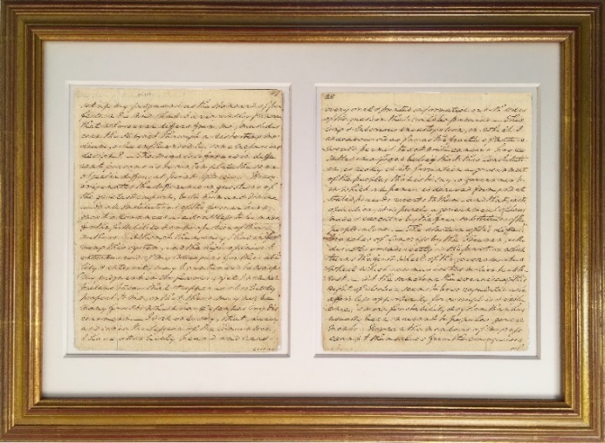
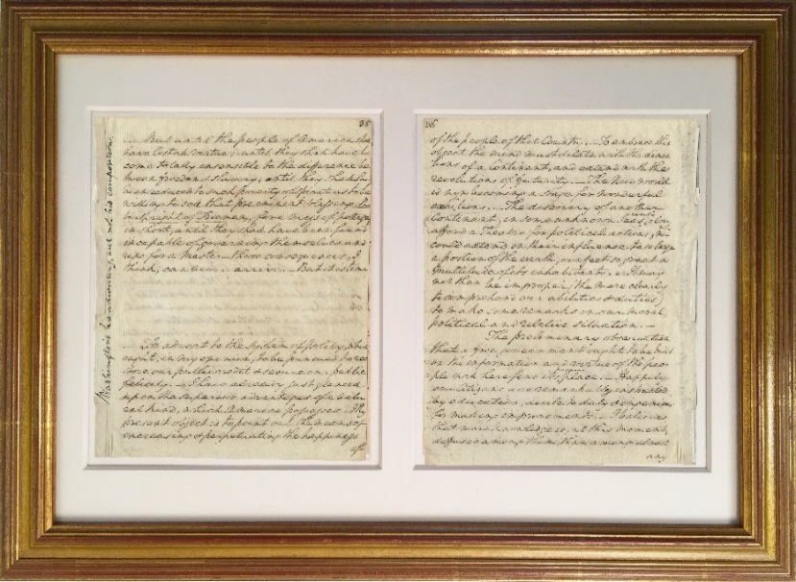
27-28 set up my judgment as the standard of perfection? And shall I arrogantly pronounce that whosoever differs from me, must discern the subject through a distorting medium, or be influenced by some nefarious design? The mind is so formed in different persons as to contemplate the same object in different points of view. Hence originates the difference on questions of the greatest import, both human & divine. In all Institutions of the former kind, great allowances are doubtless to be made for the fallibility & imperfection of their authors. Although the agency I had in forming this system, and the high opinion I entertained of my Colleagues for their ability & integrity may have tended to warp my judgment in its favour; yet I will not pretend to say that it appears absolutely perfect to me, or that there may not be many faults which have escaped my discernment. I will only say, that, during and since the Session of the Convention, I have attentively heard and read every <28> oral & printed information on both sides of the question that could be procured. This long & laborious investigation, in which I endeavoured as far as the frailty of nature would permit to act with candour has resulted in a fixed belief that this Constitution, is really in its formation a government of the people; that is to say, a government in which all power is derived from, and at stated periods reverts to them--and that, in its operation, it is purely, a government of Laws made & executed by the fair substitutes of the people alone. The election of the differ^{t} branches of Congress by the Freemen, either directly or indirectly is the pivot on which turns the first wheel of the government--a wheel which communicates motion to all the rest. At the sametime the exercise of this right of election seems to be so regulated as to afford less opportunity for corruption & influence; & more for stability & system than has usually been incident to popular governments. Nor can the members of Congress exempt themselves from the consequences of [K#24818.01]

29-30 of any unjust & tyranical acts which they may impose upon others. For in a short time they will mingle with the mass of the people. Their interests must therefore be the same, and their feelings in sympathy with those of their Constituents. Besides, their re-election must always depend upon the good reputation which they shall have maintained in the judgment of their fellow citizens. Hence I have been induced to conclude that this government must be less obnoxious to well-founded objections than most which have existed in the world. And in that opinion I am confirmed on three accounts: first--because every government ought to be possessed of powers adequate to the purposes for which it was instituted: Secondly, because no other or greater powers appear to me to be delegated to this government than are essential to accomplish the objects for which it was instituted, to wit, the safety & happiness of the governed: and thirdly because it is clear to my conception that no government before <30> introduced among mankind ever contained so many checks & such efficatious restraints to prevent it from degenerating into any species of oppression. It is unnecessary to be insisted upon, because it is well known, that the impotence of Congress under the former confederation, and the inexpediency of trusting more ample prerogatives to a single Body, gave birth to the different branches which constitute the present general government. Convinced as I am that the balances, arising from the distribution of the Legislative--Executive--& Judicial powers, are the best that have been instituted; I presume not to assert, that better may not still be devised. On the article of proposed amendments I shall say a few words in another place. But if it was a point acknowledged on all parts that the late federal government could not have existed much longer; if without some speedy remedy a dissolution of the Union must have ensued, if without adhering to the Union we [Pierpont Morgan Library] could have no security against falling a prey to foreign invasion or domestic usurpation; if upon our adherence to the union depended the protection of our property at home, and the profits of our commerce abroad; if the almost unanimous agreement of the federal Convention upon this plan of government, under the local prejudices and various expectations of the States, could be deemed little short of miraculous; if there was an easy provision made for the correction of such errors as should be found, from the imbecility of human nature, to have insinuated themselves into it; and if, upon a rejection previous to amendments, there did not appear any probability that the same system could be soon enough amended, or any other substituted in its place by another Convention—surely no State ought to have rejected it without pondering well on the consequences: because, anarchy and civil war, with an eventual government of chance or force, appeared but too probable consequences of a general rejection.

33-34 on the one hand and an unalterable habit of error on the other, are points in policy equally desirable; though, I believe, a power to effect them never before existed. Whether the Constitutional door that is opened for amendments in ours, be not the wisest and apparently the happiest expedient that has ever been suggested by human prudence I leave to every unprejudiced mind to determine.

Under these circumstances I conclude it has been the part of wisdom to ad<opt> it. I pretend to no unusual foresigh<t> into futurity, & therefore cannot und<er> take to decide, with certainty, what may be its ultimate fate. If a promised good should terminate in an unexpected evil, it would not be a solitary example
of disappointment in this mutable state of existence. If the blessings of Heaven showered thick around us should be spilled on the ground or converted to curses, through the fault of those for whom they were intended, it would not be the first instance of folly <34> or perverseness in short-sighted mortals. The blessed Religion revealed in the word of God will remain an eternal and awful monument to prove that the best Institutions may be abused by human depravity; and that they may even, in some instances be made subservient to the vilest of purposes. Should, hereafter, those who are intrusted with the management of this government, incited by the lust of power & prompted by the supineness or venality of their Constituents, overleap the known barriers of this Constitution and violate the unalienable rights of humanity: it will only serve to shew, that no compact among men (however provident in its construction & sacred in its ratification) can be pronounced everlasting and inviolable--and if I may so express myself, that no wall of words--that no mound of parchmt can be so formed as to stand against the sweeping torrent of boundless ambition on the one side, aided by the sapping current of corrupted morals on the other. But [MHS]

35-36 But until the people of America shall have lost all virtue; until they shall have become totally insensible to the difference between freedom & slavery; until they shall have been reduced to such poverty of spirit as to be willing to sell that pre-eminent blessing, the birthright of Freemen, for a mess of pottage; in short, until they shall have been found incapable of governing themselves and ripe for a master - those consequences, I think, can never arrive. But it is time To advert to the system of policy, which ought, in my opinion, to be pursued to restore our public credit & secure our public felicity. I have already just glanced upon the superior advantages of a natural kind, which America possesses. My present object is to point out the means of encreasing & perpetuating the happiness of <36> the people of that Country. To embrace this object the mind must dilate with the dimentions of a Continent, and extend with the revolutions of futurity. The New world is now becoming a stage for wonderful exhibitions. The discovery of another Continent, in some unknown Seas, could alone afford a Theatre for political actions; wch could extend in their influence to so large a portion of the earth, or affect so great a multitude of its inhabitants. It may not then be improper (the more clearly to comprehend our abilities & duties) to make some remarks on our moral, political and relative situation.
The preliminary observation that a free government ought to be built on the information and virtue of the people will here find its proper place. Happily our Citizens are remarkably instructed by education, docile to duty & ingenious for making improvements. I believe, that more knowledge is, at this moment, diffused among them, than among almost [K# 24818.02]
any other people under heaven. The conduct and issue of the late war may be a criterion to decide, whether they are destitute of wisdom in the cabinet, or fortitude in the field. For investigation of the rights of man, for ingenuity in applying principles already discovered to works of mechanism, for inventions in useful arts, and for researches in several branches of philosophy, few have gone before them. Even for efforts of genius, in some of the finer arts, they are thought, by the best judges, scarcely to have been excelled in the present age. The world has applauded their public writings, for the good sense and manly diction by which they are distinguished.

Likely [39-40] or [41-42] It might naturally be supposed that I should not silently pass by the subject of our defence. After excepting the unprovoked hostility committed against us by one of the Powers of Barbary, we are now at peace with all the nations of the globe. Seperated as we are from them, by intervening Oceans, an exemption from the burden of maintaining numerous fleets and Armies must ever be considered as a singular felicity in our National lot. It will be in our choice to train our youths to such industrious & hardy professions as that they may grow into an unconquerable force, without our being obliged to draw unprofitable Drones from the hive of Industry. As our people have a natural genius for Naval affairs & as our materials for navigation are ample; if we give due encouragement to the fisheries and the carrying trade, we shall possess such a nursery of Seamen & such skill in maratime operations as to enable us to create a navy <page break>

navy almost in a moment. But it will be wise to anticipate events & to lay a foundation in time. Whenever the circumstances will permit, a grand provision of warlike stores, arsenals and dock-yards ought to be made.

As to any invasion that might be meditated by foreigners against us on the land, I will only say, that, if the Mighty Nation with which we lately contended could not bring us under the yoke, no nation on the face of the earth can ever effect it; while we shall remain United & faithful to ourselves. A well organised Militia would constitute a strong defence; of course, your most serious attention will be turned to such an establishment. In your recess, it will give me pleasure, by making such reviews, as opportunities may allow, to attempt to revive the antient military spirit. During the present impoverished state of our Finances I would not wish to see any expence incurred by augmenting our regular [army] [Gilder Lehrman Collection #00639.25]

45 [top of page] of this government, it may be proper to give assurances of our friendly dispositions to other Powers. We may more at our leisure, meditate on such Treaties of Amity & Commerce, as shall be judged expedient to be propounded to or received from any of the<m.>

In all our appointments of persons to fill domestic & foreign offices, let us be careful to select only such as are distinguished for morals & abilities--Som<e> attention should likewise be paid, when [K#26032]

[end of page] ever the circumstances will conveniently admit, to the distribution of Offices among persons, belonging to the different parts of the Union. But my knowledge of the characters of persons, through an extent of fifteen hundred miles, must be so imperfect as to make me liable to fall into mistakes: which, in fact, can only be avoided by the disinterested aid of my coadjutors. I forbear to enlarge on the delicacy there certainly will be, in discharging this part of our trust with fidelity, and without giving occasion for uneasiness. It

46 [top of page] It appears to me, that it would be a favorable circumstance, if the characters of Candidates could be known, without their having a pretext for coming forward themselves with personal applications. We should seek to find the Men who are best qualified to fill Offices: but never give our consent to the creation of Offices to accomodate men [K#26032]

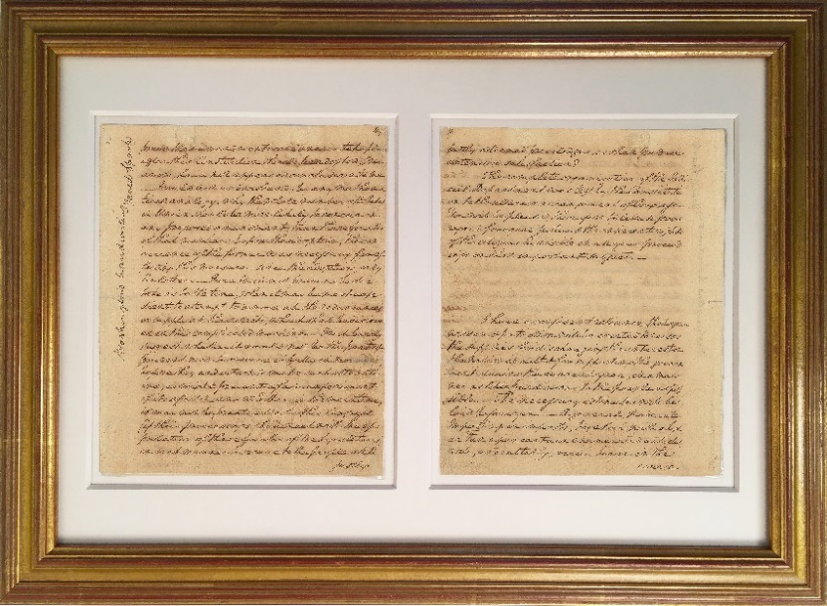
[end of page] Certain propositions for taking measures to obtain explanations & amendments on some articles of the Constitution, with the obvious intention of quieting the minds of the good people of these United States, will come before you & claim a dispassionate consideration. Whatever may not be deemed incompatible with the fundamental principles of a <free> efficient government ought to be done for the accomplishment of so desirable an object. The reasoning which have been used, to prove

47-48 prove that amendments could never take place after this Constitution should be adopted, I must avow, have not appeared conclusive to me. I could not understand, by any mathematical analogy, why the whole number of States in Union should be more likely to concur in any proposed amendment, than three fourths of that number: before the adoption, the concurrence of the former was necessary for effecting this measure--since the adoption, only the latter. Here I will not presume to dictate as to the time, when it may be most expedient to attempt to remove all the redundances or supply all the defects, which shall be discovered in this complicated machine. I will barely suggest, whether it would not be the part of prudent men to observe it fully in movement, before they undertook to make such alterations, as might prevent a fair experiment of its effects?--and whether, in the meantime, it may not be practicable for this Congress (if their proceedings shall meet with the approbation of three fourths of the Legislatures) in such manner to secure to the people all their justly- <48> esteemed priviledges as shall produce extensive satisfaction?

The complete organization of the Judicial Department was left by the Constitution to the ulterior arrangement of Congress. You [the First Session of Congress] will be pleased therefore to let a supreme regard for equal justice & the inherent rights of the citizens be visible in all your proceedings on that important subject.

I have a confident reliance that your wisdom & patriotism will be exerted to raise the supplies for discharging the interest on the national debt & for supporting the government during the current year, in a manner as little burdensome to the people as possible. The necessary estimates will be laid before you. A general, moderate Impost upon imports; together with a higher tax upon certain enumerated articles, will, undoubtedly, occur to you in the course [K# 24818.03]

49-50 course of your deliberations. I shall readily give my assent to any prudent measures. But my individual opinion would not be in favour of making frequent & rash experiments. I will only observe that it is commonly impolitic to lay duties so high, as to tempt the Importer to evade the collection by Smuggling. In whatsoever light smuggling may have been viewed heretofore, as it will now greatly injure the fair trader, & inasmuch as whatever it may detract from the revenues must be made good in some other way; it should not only be considered as an infamous practice, but even as a public robbery. The mode of collection, too, ought to be the simplest & most cogent that can be devised, without having any thing oppressive or vexatious in it. Everything we can wish is to be expected from prudence & perseverance. The unlocated land, with good management, will be a permanent & productive fund for extinguishing the national debt. In the intermediate arrangements for the Treasury, it will belong <50> to you to see, that the strictest œconomy shall be observed in the different departments, and that not one farthing of public money be wantonly squandered or wickedly misapplied. Whensoever the People shall be persuaded of this watchfulness over the pecuniary interests of the Community, I flatter myself, they will most chearfully contribute a part of their substance to supply the public demands. Especially as, under this system, taxes must be lighter in this Country, than in any other civilized country of the world. It is in my conception, worth the pains of an attempt, to endeavour to conciliate the good will of every description of honest men, when it can honestly be done. In conformity to this sentiment, I could wish to relieve the tender consciences of that industrious, frugal & valuable sect, who are religiously principled against supporting an armed force, by faithfully appropriating the whole monies which shall be collected from them, to the support of civil government, or the payment [GLC #04443.01]

57-58 of the soil and the Sea, for the wares and merchandize of other Nations is open to all. Notwithstanding the embarassments under which our trade has hitherto laboured, since the peace, the enterprising spirit of our citizens has steered our Vessels to almost every region of the known world. In some distant & heretofore unfrequented countries, our new Constellation has been received with tokens of uncommon regard. An energetic government will give to our flag still greater respect: While a sense of reciprocal benefits will serve to connect us with the rest of mankind in stricter ties of amity. But an internal commerce is more in our power; and may be of more importance. The surplus of produce in one part of the United States, will, in many instances, be wanted in another. An intercourse of this kind is well calculated to multiply Sailors, exterminate prejudices, diffuse blessings, and encrease the friendship of the inhabitants of one State for those of another. While <58> the individual States shall be occupied in facilitating the means of transportation, by opening canals & improving roads: you will not forget that the purposes of business & Society may be vastly promoted by giving cheapness, dispatch & security to communications through the regular Posts. I need not say how satisfactory it would be, to gratify the useful curiosity of our citizens by the conveyance of News Papers & periodical Publications in the public vehicles without expence.

Notwithstanding the rapid growth of our population, from the facility of obtaining subsistence, as well as from the accession of strangers, yet we shall not soon become a manufacturing people. Because men are even better pleased with labouring on their farms, than in their workshops. Even the mechanics who come from Europe, as soon as they can procure a little land of their own, commonly turn Cultivators. Hence it will be found more beneficial, I believe, to continue to exchange [GLC #01589]

59-60 change our Staple commodities for the finer manufactures we may want, than to undertake to make them ourselves. Many articles, however, in wool, flax, cotton, & hemp; and all in leather, iron, fur and wood may be fabricated at home with great advantage. If the quantity of wool, flax, cotton & hemp should be encreased to ten-fold its present amount (as it easily could be) I apprehend the whole might in a short time be manufactured. Especially by the introduction of machines for multiplying the effects of labour, in diminishing the number of hands employed upon it. But it will rest with you to investigate what proficiency we are capable of making in manufactures, and what encouragement should be given to particular branches of them. In almost every House, much Spinning might be done by hands which otherwise would be in a manner idle <60> It remains for you to make, out of a Country poor in the precious metals and comparatively thin of inhabitants a flourishing State. But here it is particularly incumbent on me to express my idea of a flourishing state with precision; and to distinguish between happiness & splendour. The people of this Country may doubtless enjoy all the great blessings of the social State: and yet United America may not for a long time to come make a brilliant figure as a nation, among the nations of the earth. Should this be the case, and should the people be actuated by principles of true magnanimity, they will not suffer their ambition to be awakened. They should guard against ambition as against their greatest enemy. We shou'd not, in imitation of some nations which have been celebrated for a false kind of patriotism, wish to aggrandize our own Republic at the expence of the freedom & happiness of the rest of mankind. The prospect that the Americans will not act upon so narrow a scale affords the most comfortable [Private]

61-62 ble reflections to a benevolent mind. As their remoteness from other nations in a manner precludes them from foreign quarrels: so their extent of territory & gradual settlement, will enable them to maintain something like a war of posts, against the invasion of luxury, dissipation, & corruption. For after the large cities & old establishments on the borders of the Atlantic, shall, in the progress of time, have fallen a prey to those Invaders; the Western States will probably long retain their primaeval simplicity of manners & incorruptible love of liberty. May we not reasonably expect, that, by those manners & this patriotism, uncommon prosperity will be entailed on the civil institutions of the American world? And may you not console yourselves for any irksome circumstances which shall occur in the performance of your task, with the pleasing consideration, that you are now employed in laying the foundation of that durable prosperity <62> It belongs to you especially to take measures for promoting the general welfare. It belongs to you to make men honest in their dealings with each other, by regulating the coinage & currency of money upon equitable principles as well as by establishing just weights and measures upon an uniform plan. Whenever an opportunity shall be furnished to you as public or as private men, I trust you will not fail to use your best endeavors to improve the education and manners of a people; to accelerate the progress of arts & Sciences; to patronize works of genius; to confer rewards for inventions of utility; and to cherish institutions favourable to humanity. Such are among the best of all human employments. Such exertion of your talents will render your situations truly dignified & cannot fail of being acceptable in the sight of the Divinity.

By a series of disinterested services it will be in our power to shew, that we have nothing [Private]

[63-73?] [recto(?)] While others in their political conduct shall demean themselves as may seem <dear> to them, let us be honest. Let us be firm. Let us advance directly forward in the path of our duty. Should the path at first prove intricate & thorny, it will grow plain and smooth as we go. In public as in private life, let the eternal line that separates right from wrong, be the fence <to>

[63-73? bottom [verso(?)] I have now again given way to my feelings, in speaking without reserve, according to my best judgment, the words of soberness & affection. If any thing indiscreet or foreign to the occasion has been spoken, your candour, I am convinced will not impute it to an unworthy motive. I come now to a conclusion by addressing my humble petition to the

[63-73? bottom] which will conduce to their temporal & eternal peace--I most earnestly supplicate that Almighty God, to whose holy keeping I commend my dearest Country, will never offer so fair an inheritance to become a prey to avar [Duke University, Rolfe Smith Saunders Papers. Verso?]

Text of Washington’s Delivered First Inaugural Address

[April 30, 1789]
Fellow Citizens of the Senate and the House of Representatives.

Among the vicissitudes incident to life, no event could have filled me with greater anxieties than that of which the notification was transmitted by your order, and received on the fourteenth day of the present month. On the one hand, I was summoned by my Country, whose voice I can never hear but with veneration and love, from a retreat which I had chosen with the fondest predilection, and, in my flattering hopes, with an immutable decision, as the asylum of my declining years: a retreat which was rendered every day more necessary as well as more dear to me, by the addition of habit to inclination, and of frequent interruptions in my health to the gradual waste committed on it by time. On the other hand, the magnitude and difficulty of the trust to which the voice of my Country called me, being sufficient to awaken in the wisest and most experienced of her citizens, a distrustful scrutiny into his qualifications, could not but overwhelm with dispondence, one, who, inheriting inferior endowments from nature and unpractised in the duties of civil administration, ought to be peculiarly conscious of his own deficiencies. In this conflict of emotions, all I dare aver, is, that it has been my faithful study to collect my duty from a just appreciation of every circumstance, by which it might be affected. All I dare hope, is, that, if in executing this task I have been too much swayed by a grateful remembrance of former instances, or by an affectionate sensibility to this transcendent proof, of the confidence of my fellow-citizens; and have thence too little consulted my incapacity as well as disinclination for the weighty and untried cares before me; my error will be palliated by the motives which misled me, and its consequences be judged by my Country, with some share of the partiality in which they originated.

Such being the impressions under which I have, in obedience to the
public summons, repaired to the present station; it would be peculiarly improper to omit in this first official Act, my fervent supplications to that Almighty Being who rules over the Universe, who presides in the Councils of Nations, and whose providential aids can supply every human defect, that his benediction may consecrate to the liberties and happiness of the People of the United States, a Government instituted by themselves for these essential purposes: and may enable every instrument employed in its administration to execute with success, the functions allotted to his charge. In tendering this homage to the Great Author of every public and private good I assure myself that it expresses your sentiments not less than my own; nor those of my fellow-citizens at large, less than either. No People can be bound to acknowledge and adore the invisible hand, which conducts the Affairs of men more than the People of the United States. Every step, by which they have advanced to the character of an independent nation, seems to have been distinguished by some token of providential agency. And in the important revolution just accomplished in the system of their United Government, the tranquil deliberations and voluntary consent of so many distinct communities, from which the event has resulted, cannot be compared with the means by which most Governments have been established, without some return of pious gratitude along with an humble anticipation of the future blessings which the past seem to presage. These reflections, arising out of the present crisis, have forced themselves too strongly on my mind to be suppressed. You will join with me I trust in thinking, that there are none under the influence of which, the proceedings of a new and free Government can more auspiciously commence.

By the article establishing the Executive Department, it is made the duty of the President "to recommend to your consideration, such measures as he shall judge necessary and expedient." The circumstances under which I now meet you, will acquit me from entering into that subject, farther than to refer to the Great Constitutional Charter under which you are assembled; and which, in defining your powers, designates the objects to which your attention is to be given. It will be more consistent with those circumstances, and far more congenial with the feelings which actuate me, to substitute, in place of a recommendation of particular measures, the tribute that is due to the talents, the rectitude, and the patriotism which adorn the characters selected to devise and adopt them. In these honorable qualifications, I behold the surest pledges, that as on one side, no local prejudices, or attachments; no seperate views, nor party animosities, will misdirect the comprehensive and equal eye which ought to watch over this great assemblage of communities and interests: so, on another, that the foundations of our National policy will be laid in the pure and immutable principles of private morality; and the pre-eminence of a free Government, be exemplified by all the attributes which can win the affections of its Citizens, and command the respect of the world.

I dwell on this prospect with every satisfaction which an ardent love for my Country can inspire: since there is no truth more thoroughly established, than that there exists in the economy and course of nature, an indissoluble union between virtue and happiness, between duty and advantage, between the genuine maxims of an honest and magnanimous policy, and the solid rewards of public prosperity and felicity: Since we ought to be no less persuaded that the propitious smiles of Heaven, can never be expected on a nation that disregards the eternal rules of order and right, which Heaven itself has ordained: And since the preservation of the sacred fire of liberty, and the destiny of the Republican model of Government, are justly considered as deeply, perhaps as finally staked, on the experiment entrusted to the hands of the American people.

Besides the ordinary objects submitted to your care, it will remain with your judgment to decide, how far an exercise of the occasional power delegated by the Fifth article of the Constitution is rendered expedient at the present juncture by the nature of objections which have been urged against the System, or by the degree of inquietude which has given birth to them. Instead of undertaking particular recommendations on this subject, in which I could be guided by no lights derived from official opportunities, I shall again give way to my entire confidence in your discernment and pursuit of the public good: For I assure myself that whilst you carefully avoid every alteration which might endanger the benefits of an United and effective Government, or which ought to await the future lessons of experience; a reverence for the characteristic rights of freemen, and a regard for the public harmony, will sufficiently influence your deliberations on the question how far the former can be more impregnably fortified, or the latter be safely and advantageously promoted.

To the preceeding observations I have one to add, which will be most properly addressed to the House of Representatives. It concerns myself, and will therefore be as brief as possible. When I was first honoured with a call into the Service of my Country, then on the eve of an arduous struggle for its liberties, the light in which I contemplated my duty required that I should renounce every pecuniary compensation. From this resolution I have in no instance departed. And being still under the impressions which produced it, I must decline as inapplicable to myself, any share in the personal emoluments, which may be indispensably included in a permanent provision for the Executive Department; and must accordingly pray that the pecuniary estimates for the Station in which I am placed, may, during my continuance in it, be limited to such actual expenditures as the public good may be thought to require.

Having thus imported to you my sentiments, as they have been awakened by the occasion which brings us together, I shall take my present leave; but not without resorting once more to the benign parent of the human race, in humble supplication that since he has been pleased to favour the American people, with opportunities for deliberating in perfect tranquility, and dispositions for deciding with unparalleled unanimity on a form of Government, for the security of their Union, and the advancement of their happiness; so his divine blessing may be equally conspicuous in the enlarged views, the temperate consultations, and the wise measures on which the success of this Government must depend.

-----------------------------

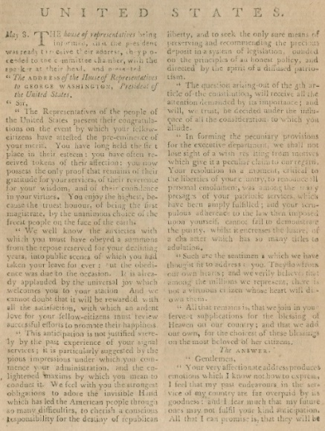
It was not at all surprising that Congress chose James Madison to draft their response thanking Washington for his address. In it, he praised Washington’s support of the Constitution and deferral to Congress on the process of amendments.

Ironically, Washington then turned to none other than James Madison to craft his endorsement of Congress’ wise use of such legislative powers.
Columbian Magazine, May, 1789
About Seth Kaller

Seth Kaller is a leading expert in acquiring and authenticating American historic documents and artifacts. Kaller has built museum-quality collections for individuals and institutions, as well as philanthropic legacy collections.

Seth has represented the Gilder Lehrman Collection since its inception in 1989, building it into one of the most important American history collections ever privately formed.

His acquisitions include James Madison’s copy of the Declaration of Independence, working drafts of the U.S. Constitution, Abraham Lincoln’s “House Divided” Speech and signed copies of the Emancipation Proclamation and the 13th Amendment, Albert Einstein’s first scientific paper, and many other documents that changed the course of history.

Kaller’s acquisitions have been exhibited at the Smithsonian, the Library of Congress, the New-York Historical Society, The National Constitution Center, George Washington’s Mount Vernon, Rice University, Federal Hall, and other notable sites.

Acquiring this Collection

We are pleased to offer this museum quality collection.

For philanthropic buyers, we have unparalleled experience with appropriate museums and libraries that would welcome the collection on loan or deposit.

We are advising and assisting the Harbor Conservancy, the non-profit managing the revitalization of Federal Hall, a National Parks historic monument. Their upgraded exhibit space will not be ready until 2020, but they would be thrilled to have a future opportunity to bring Washington’s Manifesto on Government to the spot where he delivered his first inaugural address, right across from today’s New York Stock Exchange. Please inquire about Federal Hall’s plan to make these documents a central feature of a Dead Sea Scrolls-like exhibit in the Vault.

We are also working with George Washington’s Mount Vernon on gathering and sharing images of any of the surviving fragments, including those in institutional and private collections. We will soon reunite as much of the address as possible, for the first time, online.

We are happy to work with “hands-on” owners as well as clients who prefer us to handle all aspects of housing, insuring, displaying, safeguarding, and sharing the collection.

We can also assist with planning aimed at maximizing tax advantages if ultimate gifting is a consideration.

Penned by Washington himself, these pages provide the greatest surviving artifactual evidence of his compelling and comprehensive vision of a new government built on core American values.

Beyond rarity and iconic value considerations, it is the content that makes Washington’s speech a perfect fit for any individual or institution interested in preserving and promoting American history.

Whether for your personal and patriotic interest, or for your company, your foundation, or your alma mater, please call if you’d like to explore this unique opportunity to take ownership of history.
- Seth Kaller

914-289-1776 seth@sethkaller.com

The Alexander Hamilton Collection: The Story of the Revolution and Founding.
Highly Important Original Letters, Documents, & Imprints Featuring Hamilton,
Washington, Jefferson, Adams, Paine, Burr, the Schuyler Sisters and Brothers, & Many More.

Telling political and personal tales of the brilliant and sometimes tragic Founders, this Collection of more than 1,100 original documents, offered as a whole, includes:

- A very rare July 8, 1776 Declaration of Independence imprint;

- George Washington’s letter transmitting the Act establishing the Treasury Department;

- One of Hamilton’s most revealing love letters to Eliza;

- Scarce printings of Hamilton’s financial plans;

- A document signed by Hamilton and Eliza and Angelica and other Schuyler sisters, brothers and assorted relatives;
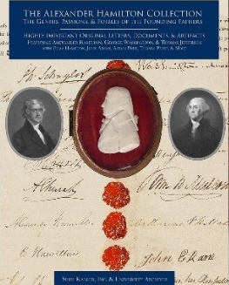
- A rare first edition of the Reynolds Pamphlet, with a scarce second edition printed by Hamilton’s enemies (Yes, the Collection captures age-old stories of hubris, infidelity, scandal, and tragedy - human flaws that make the triumphs even more amazing);

- Important letters and documents signed by Washington, Adams, Jefferson, Hamilton, Burr, Madison, Franklin, Paine, Hancock, etc.;

- Rare Acts of Congress signed by Thomas Jefferson and Edmund Randolph;

- Hamilton’s draft of his “anyone but Jefferson” letter;

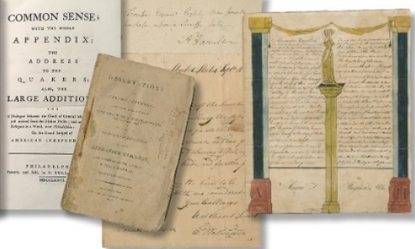
- A complete set of letters or documents of Signers of the Constitution
The domain www.AHamilton.com is included to allow these documents to be even more widely shared, either anonymously or as a legacy collection

The Alexander Hamilton Collection will, in a single acquisition, provide enough content and context to tell a riveting story of the Revolution and Founding.

Additional Historic Opportunities

Great properties that are available now, or that we have previously sold but hope to access again one day, include:

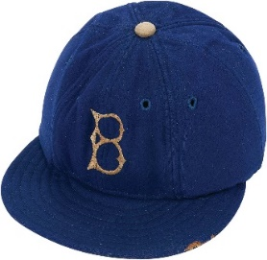
Jackie Robinson rare artifacts, including his specially padded cap, his 1949 signed Brooklyn Dodgers contract, and his Dodgers jacket, his 1952 All-Star game bat, and his glove.

Jefferson’s letters on the Declaration of Independence and Bill of Rights, one of his most famous letters on slavery, and leaves from his Manual of Parliamentary Practice.

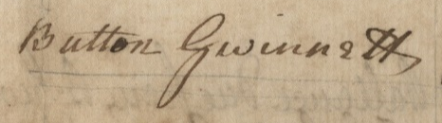
Declaration of Independence Signers - rare complete set of letters and documents, rare July 1776 printings of the Declaration, and more from the Revolutionary War and Founding.

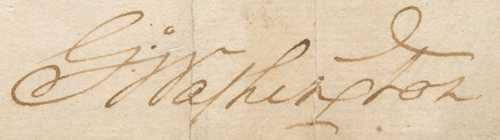
George Washington’s First Presidential Thanksgiving Proclamation, requested by Congress on the day they approved the Bill of Rights, expressing gratitude: “for the civil and religious liberty with which we are blessed; and the means we have of acquiring and diffusing useful knowledge… To render our national government a blessing… by constantly being a Government of wise, just, and Constitutional laws, discreetly and faithfully executed and obeyed.”

The Sovereignty, Embargo, and Impressment Collection, featuring John Adams, Thomas Jefferson, and James Madison. “To have submitted our rightful commerce to prohibitions and tributary exactions from others would have been to surrender our independence. To resist them by arms was war.”
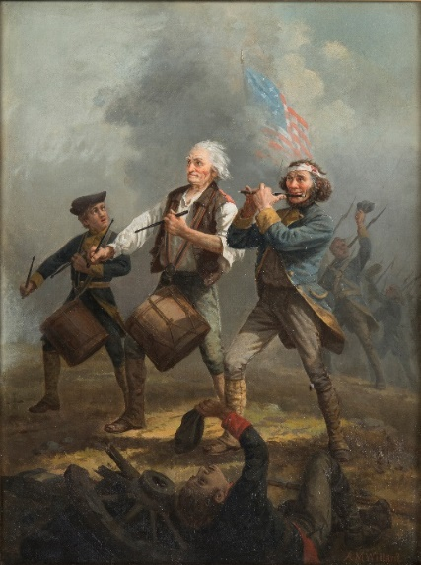
Archibald Willard’s Spirit of ’76, original oil painting upon which the iconic 1876 print was based. Sold.

James Naismith Rules of Basketball Archive.

A vibrant Rembrandt Peale painting of Washington,
ca. 1819-1822, a precursor to his “Pater Patria” portrait.

Abraham Lincoln letters and documents, including scarce printings of the Gettysburg Address and Emancipation Proclamation, and one of three known letters to his soon-to-be ex-fiancée Mary Owens.

Franklin D. Roosevelt – Missy LeHand Archive, including personal letters, copies he inscribed to her of inaugural addresses, fireside chats, books, etc. And several hundred unpublished photographs and pieces of ephemera. The most important FDR archive left in private hands.

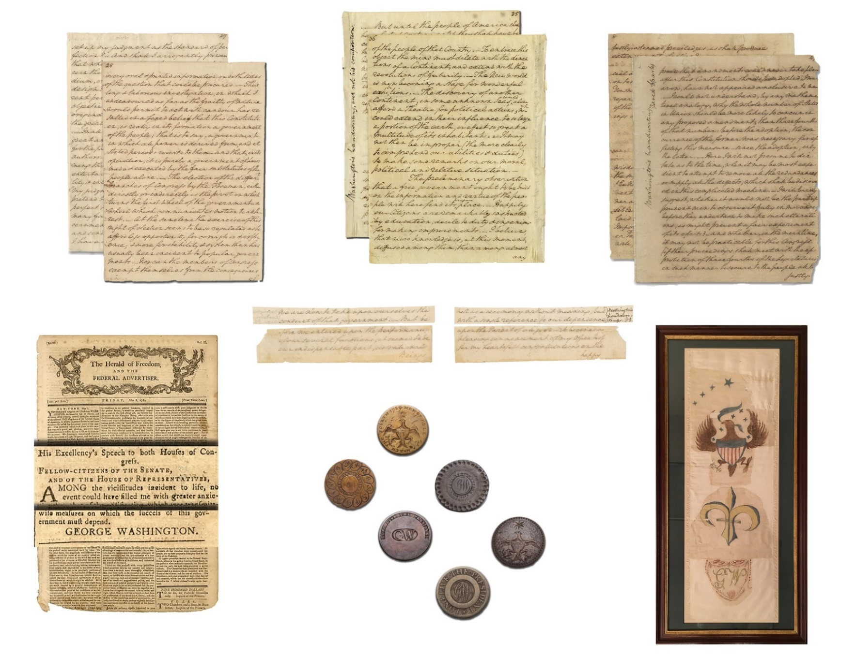

In this introduction, the numbers in parentheses refer to the page numbers Washington penned on the original manuscripts in this collection.
The original January 2 letter is now in the British Library. The original February 16 letter is in a private collection.
This was the confidential letter Washington had sent with the draft address. It is now missing; perhaps it was destroyed by Sparks.
Sparks to Madison, May 22, 1827, James Madison Papers, Library of Congress.
Jared Sparks Papers, Harvard University.
Published in The Miscellaneous Works of David Humphreys, Late Minister Plenipotentiary to the Court of Madrid (New York, 1804), 332-42.
W. B. Allen, ed. and comp., George Washington: A Collection (Indianapolis: Liberty Fund, 1988), 166-67.
Hamilton, An American Musical, by Lin Manuel Miranda. This line is sung by Aaron Burr to Hamilton, but it applies nonetheless.
Also see Editorial Note under [April 30, 1789], in The Papers of George Washington, Presidential Series, vol. 2, 1 April 1789 – 15 June 1789, ed. Dorothy Twohig, 152–157, as well as various related correspondence published there and in The Papers of James Madison. All are available online at founders.archives.gov.
Allen, 441-42
The sentence continues on p. 29, at the Pierpont Morgan Library: “of any unjust & tyranical acts which they may impose upon others.”
Begins on a fragment of page 46, last recorded in 1958 as in private hands.
Sparks, Writings, 10:463.
Fisher Ames to George Richard Minot, May 3, 1789, in Works of Fisher Ames, 2 vols. (Boston: Little, Brown, and Company, 1854), 1:34-36.
Charles A. Beard, ed., The Journal of William Maclay: United States Senator from Pennsylvania, 1789-1791 (New York, 1927), 8.
Sparks, Writings, 10:464.
Moustier to Montmorin, June 5, 1789 Arc. Nat., Aff. Etr., Corr. Pol., Etats-Unis, vol. 34, translation in Bowen, Inauguration, 47-49). Also see the Gazette of the United States (New York), May 2, 1789.
Bowen, Inauguration, 47
Sparks, Writings, 10:464.
“Undelivered First Inaugural Address: Fragments,” Dorothy Twohig, ed., The Papers of George Washington, Presidential Series, vol. 2, April 1 1789-June 15, 1789. (Charlottesville: University Press of Virginia, 1987), pp 152-58.
Fragments of Washington’s letters previously misidentified as having come from the address are excluded.
North-Carolina and Rhode-Island had not yet ratified the Constitution.
Stein had incorrectly marked 36-37.

